From Abe:
Here are some questions you can answer about 2103 which will get us started on the design:

1. How many demonstration cameras are used at once? { Several } Are there HDMI compatible demonstration cameras on the market? { Yes – I currently have 4 to 5 cheaper ones }
- Is there an expectation that this content will be "lecture captured" or recorded? { Currently somewhat rare but it is increasing }

2. Is three projectors necessary? { Definitely ! } Are different images shown on the projectors in class? { Yes! All the time. }

3. Does the room have existing lighting control from the AV system? { Only rooms 2241 and 2103 are on an antiquated ETC Unison dimmable/programmable system that is failing }

Thanks,

Abe

Below I tried to summarize each room’s current usage, function, and needs. In general, all three rooms the needs and function are relatively the same. The larger the room the more inputs we need.
AV Upgrade Request, Needs, and Functions

In Common:
- All 3 rooms should have an overflow bridge (in place) to the adjacent rooms (2241, 2223, & 2103) for overflow and special events. So that audio and video signals can be sent to a different room as well as the host room.
- All graphical, video, and audio signals from all 3 rooms should be accessible via the control room 2237 and displayable on a multi viewer(s).
- All 3 rooms should get new glass writing surfaces, preferably magnetic.
- All 3 rooms should have lecture capture systems (requested by general assignment courses).
- All rooms must have several PTZ cameras for lecture demo use and also could be used for lecture capture.
  - 2223 – No less than 2 cameras are needed – Currently has 1 (~20 year old Elmo)
  - 2241 – No less than 4 cameras are needed – Currently has 4 (~20 year old Elmo’s)
  - 2103 – No less than 7 cameras are needed – Currently has 6 (4 ~20 year old Elmo’s & 2 newer ones that are ~8yrs old)
- All room cameras should also have an external programmable PTZ Joystick controller console that can be used ether from the control room (2237) or at the room’s lectern. (One system for each room; 2241 & 2103)
- Wireless PA system in all rooms (Large infrastructure of Sennheiser is already in place)
  - 2223 – At least 1 wireless microphone – Currently has 1 newer unit
  - 2241 – No less than 4 wireless microphones – Currently has 2 newer units & 2 older units {On rare occasions we need 5 micorphones}
  - 2103 – No less than 8 wireless microphones are needed, with the ability to add more if needed – Currently this room has only 6; 4 new units & 2 older units
- All rooms should have the ability to be connected to the McBurney center for at least audio, if not video as well. For the hearing impaired for their voice to text system.
- All rooms must display simultaneous video sources along with simultaneous mixed audio signals from input sources. [We cannot have last signal sent audio, I rather have audio mutes page ]
- Foot note: Behind the writing surfaces within 2241 & 2223 there should be already in place, electrical conduit and J boxes for J fixtures that were originally planned for whiteboard lights before they realized the boards were projection surfaces.

In general we still use VGA Oscilloscopes, some SDI (Which I could live without), and video cameras with HDMI & NTSC outputs – So being able to convert to any signal to what the new system operates on is critically important. (External converter maybe an option)

Room 2241:
General Needs:
- 3 projectors are a must (all must have video mute and freeze capabilities).
- Writing surface is also necessary (Magnetic glass whiteboard is preferred by our department).
- With the new writing surfaces (glass), we will need 3 robotic screens that are preferably recessed within the ceiling cavity for the projectors and should be integrated with the controls.
- Glass board writing surfaces will require better illumination that does not interfere with the projection screens.
- This room has an antiquated ETC Unison dimmable/programmable lighting system. The system “needs” to be upgraded, physics require dimmable/programmable lighting. The function of the current system is nice, however, the hardware (blades) are failing. Currently have ~3 circuits that are out of order.
- Must have 4 ceiling cameras (back left, back right, above removable demonstrational tables 1 & 2).
- It would be extraordinarily beneficial to have the 2 cameras that are over the lecture demonstration tables mechanically move along a track that is directly above and centered on the table system below.
- This room should be converted into a full video teleconference room with audience microphones (push-to-talk?). We often have teleconferences from Fermi lab and CERN, not to mention our weekly colloquia & seminars within this room. I’d be happy with several up to (~50) push-to-talk microphones that can work on the existing CAT5 for the audience participation or any other modern method. It would be very beneficial to have a PTZ camera that is facing the audience for the remote viewers.
- This is the only room that has a SDI 3G video backbone, with some cat-7 in place.

Lectern Needs:
- Two computer input ports/cables HDMI or USB-C. (USB-C cable should be powered)
- One video w/stereo audio input port.
- At least 2 USB-C charging ports within the power wire molding.
- 2 airplay inputs to display wirelessly (or some other “reliable” wireless system) – Currently using apple TV.
- Lecture capture system for general assignment primarily, possibly used by physics.
- Total control of the system: input signals, source, PTZ camera, & data location from the control room 2237 as well as from the lectern. Room is currently controlled remotely by X-panel.
- Touch screen console for controlling the AV system must have graphic preview for all inputs.
- Document camera when needed. (Not necessarily located on lectern).
- Audio input (XLR) & audio output for Zoom sessions (mono 1/8 phono or USB converter).

Removable Demonstration Table system:
- This room as 2 tables, currently labeled as Table #1 and Table#2. Each table contains/covers 3 black utility racks underneath to support lecture demonstrations and audio/video needs.
- Each table node must have 2 computer input ports HDMI preferred but also can handle VGA.
- 2 Camera input port for portable box cameras that currently use NTSC, SDI, or HDMI for their output.
- Audio input ports (left and right channel).
- XLR audio output.
- Loop through (HDMI) video signal at each input would be great. Lecture demonstrations will supply the monitor(s) when function is needed. (Minimum of one per table)
- Note: In general both table notes should be basically identical and the removable AV carts will all need to be upgraded with the new converter.

Room 2241 photos:
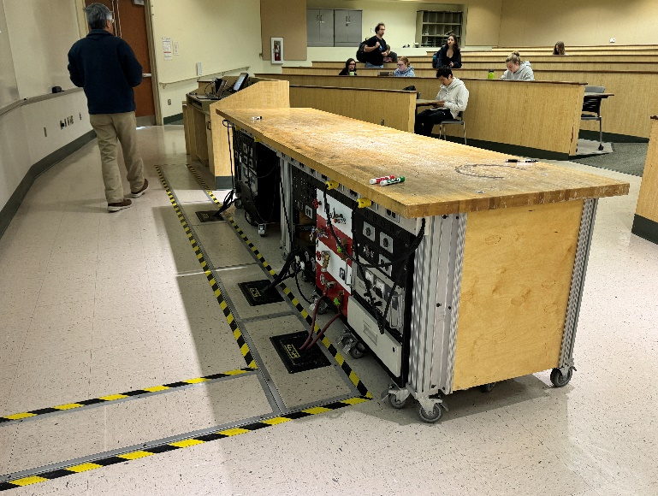
Removable demo table and demonstrational support equipment.
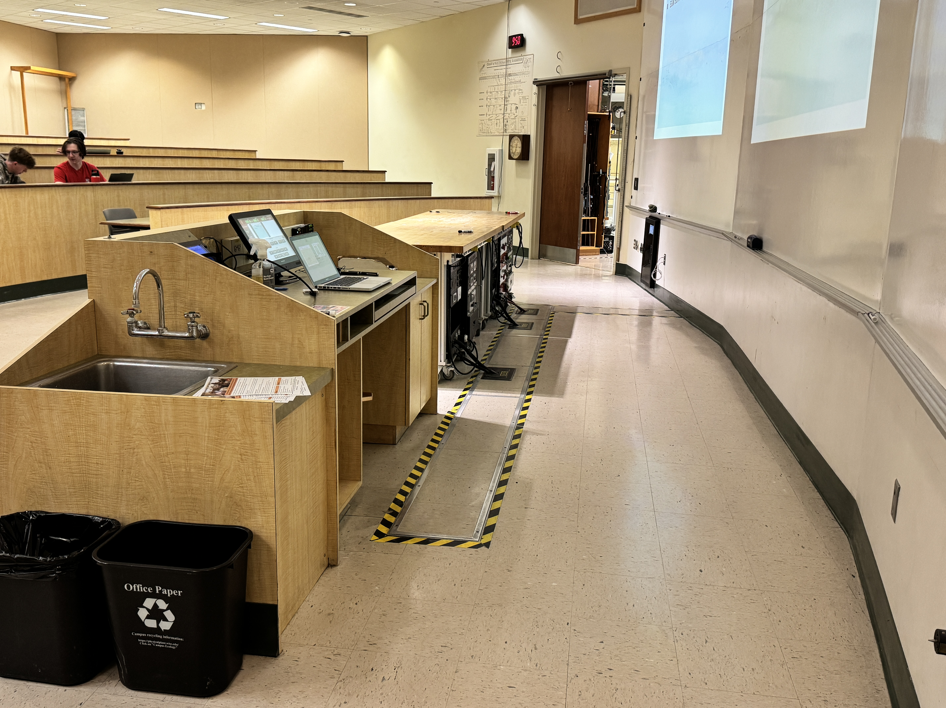

Room 2103:
General Needs:
- 3 projectors are a must (all must have video mute and freeze capabilities).
- Writing surface is also necessary (Magnetic glass whiteboard is preferred by our department) with new lights. {This could go high tech with touchable/writable screens that actually displays via the projectors – Smart board technology }
- This room also has an antiquated ETC Unison dimmable/programmable lighting system. The system “needs” to be upgraded, physics require dimmable/programmable lighting. The function of the current system is nice, however the hardware (blades) are failing. Currently have ~2 circuits that are out of order.
- Must have 7 ceiling cameras, (back left, back right, above Tables 1, 2, & 3, stage right, plus new one at stage left).
- It would be extraordinarily beneficial to have the cameras that are over the lecture demonstration tables mechanically move along a track that is directly above and centered on the table system below.
- The upper portion is strictly for projection. The old Wall-taker surface should be replaced with a better surface for projection that reduces hot spots.
- Large movement to get new controllable stage (theater) lights for annual Wonders of physics shows. Some funds have been set aside already for this.
- Note: It is more convenient to plug computers in for lectures via Table #2 then at the lectern.

Projector room:
- The projectors need to be very bright for the distance that they are throwing the image.
- The current projector holes within the concrete wall may need to be widened. They are actually too small for the projectors we currently have.

Lectern Needs:
- Two computer input ports HDMI or USB-C. (USB-C cable should be powered)
- One video w/stereo audio input port.
- At least 2 USB-C charging ports within the power wire molding.
- 2 airplay inputs to display wirelessly (or some other “reliable” wireless system) – Currently using Apple TV.
- Lecture capture system for general assignment primarily, possibly used by physics.
- Total control of the system: input signals, source, PTZ camera, & data location from the control room 2237 as well as from the lectern. Room is currently controlled remotely by X-panel.
- Touch screen console for controlling the AV system must have graphic preview for all inputs.
- Document camera when needed. (Not fixed at lectern).
- Audio input (XLR) & audio output for Zoom sessions (mono 1/8 phono or USB converter). In two locations the lectern and Table #2.
- Programmable external multi-viewer for Wonders of Physics.

Removable Demonstration Table system:
- This room as 3 tables, currently labeled as Table #1, Table #2, & Table #3. Each table contains/covers 3 black utility racks underneath to support lecture demonstrations and audio/video needs.
- A second way to control the projectors (freeze & mutes functions) from demonstrational table #2 – Currently using projector remote control via IR relay. This can be either full control of the system or partial. Total and main A/V controls will still be lectern.
- The addition of a 4th Table node is desperately needed for lecture demonstrations. This table will also require its own ceiling mounted PTZ camera on a track.
- Each table node must have 2 computer input ports, HDMI is preferred but also can handle VGA.
- 2 Camera input port for portable box cameras that use NTSC, SDI, or HDMI for their output.
- Audio input points (left and right channel).
- XLR audio output.
- Loop through (HDMI) video signal at each input would be great. Lecture demonstrations will supply the monitor(s) when function is needed. (Minimum of one per table)
- Note: In general all 4 table notes should be basically identical and the removable AV carts will all need to be upgraded with the new converter.

Room 2103 photos:
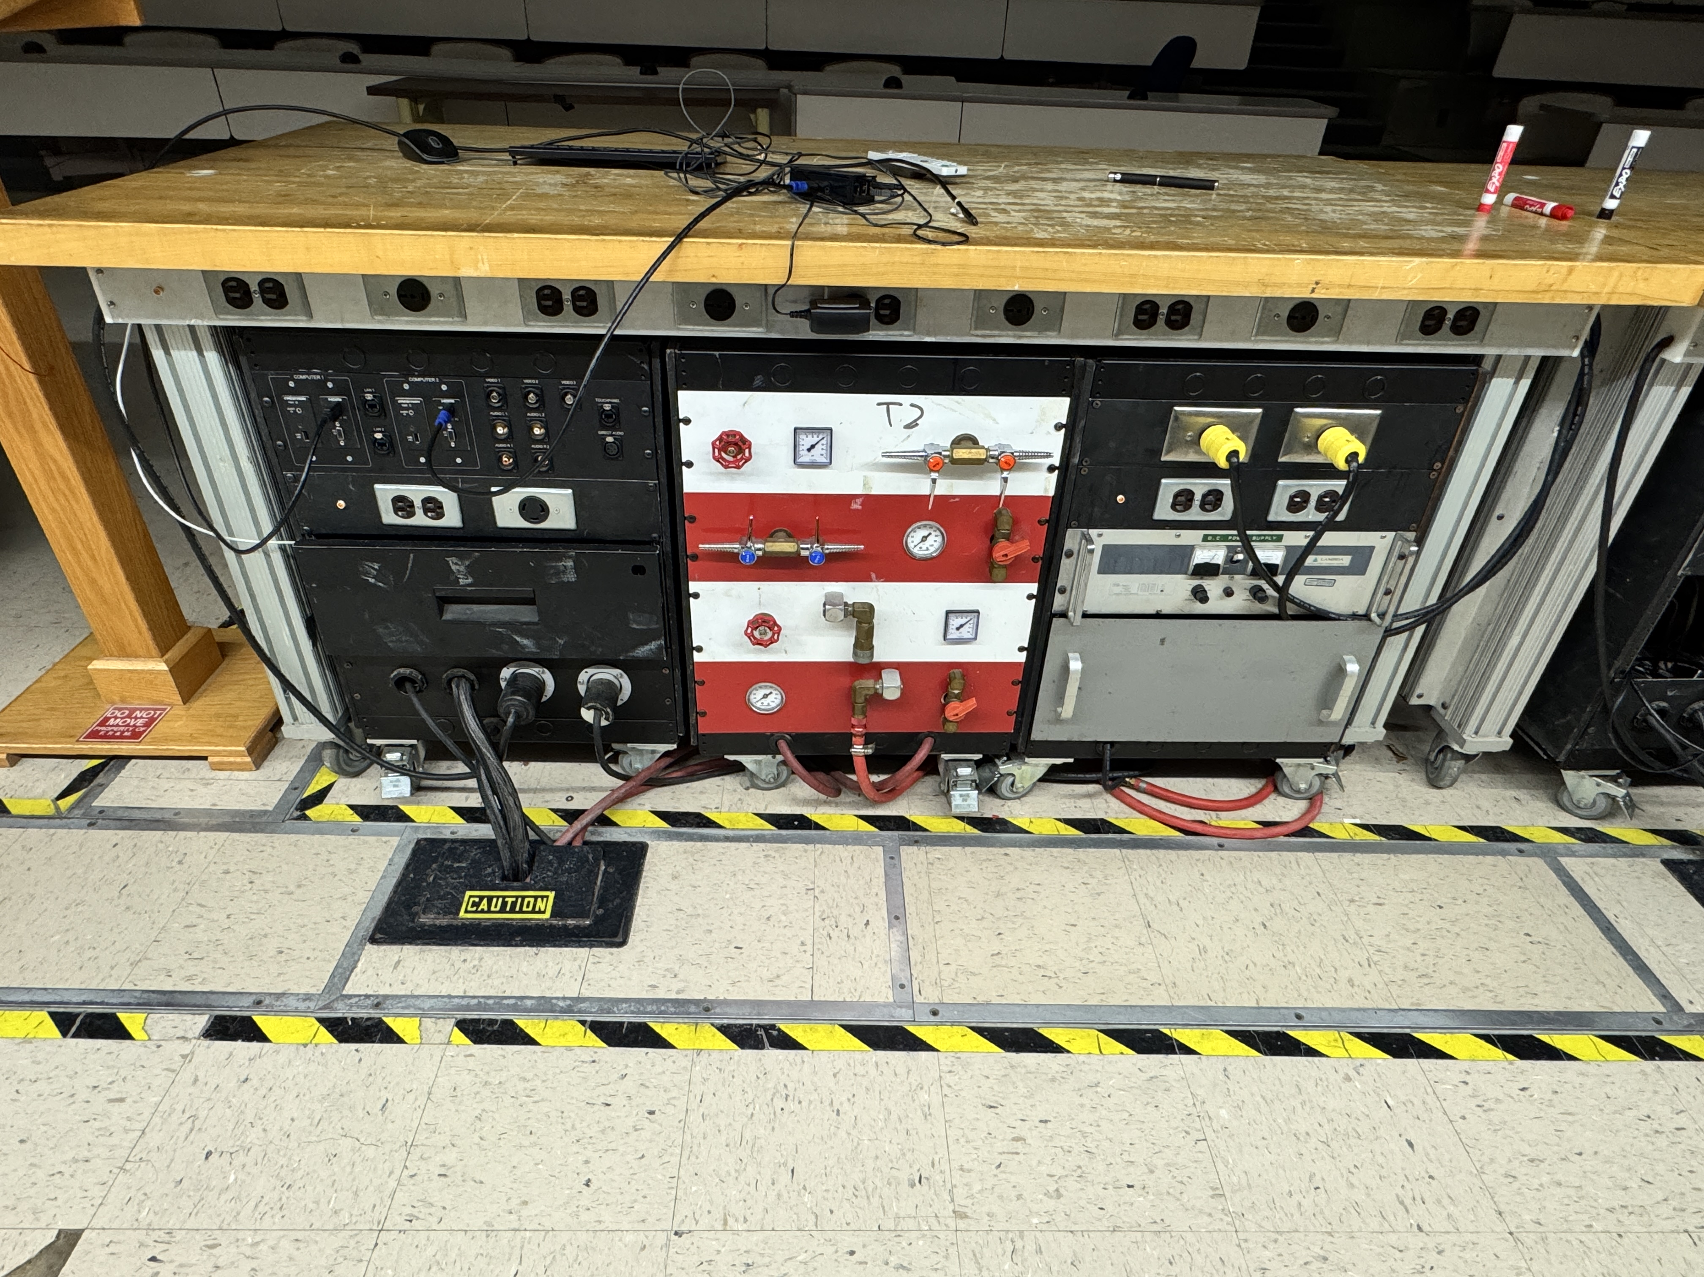Removable demonstrational table (this one is Table#2) and demonstrational support equipment (3 equipment racks beneath). Left to right: AV cart, Gas cart, DC power cart. Sometimes vacuum pump. (Same as room 2241)
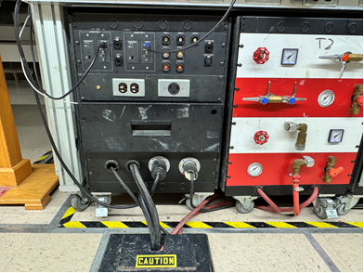
All AV carts currently consists of 2 graphical ports, either VGA or HDMI, 2 video ports with audio, one video port without audio, microphone input port, and 2 network lines. Some of these lines can be bidirectional via control room patching. (Same as room 2241)
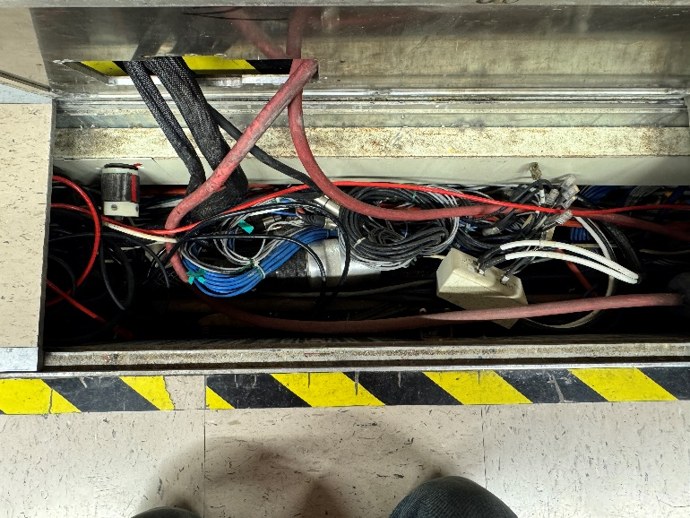
AV cables consists of a multi-pin connector and 3 newer CAT cables. Connect the cart above to the cables within the floor trench. (Same as room 2241)
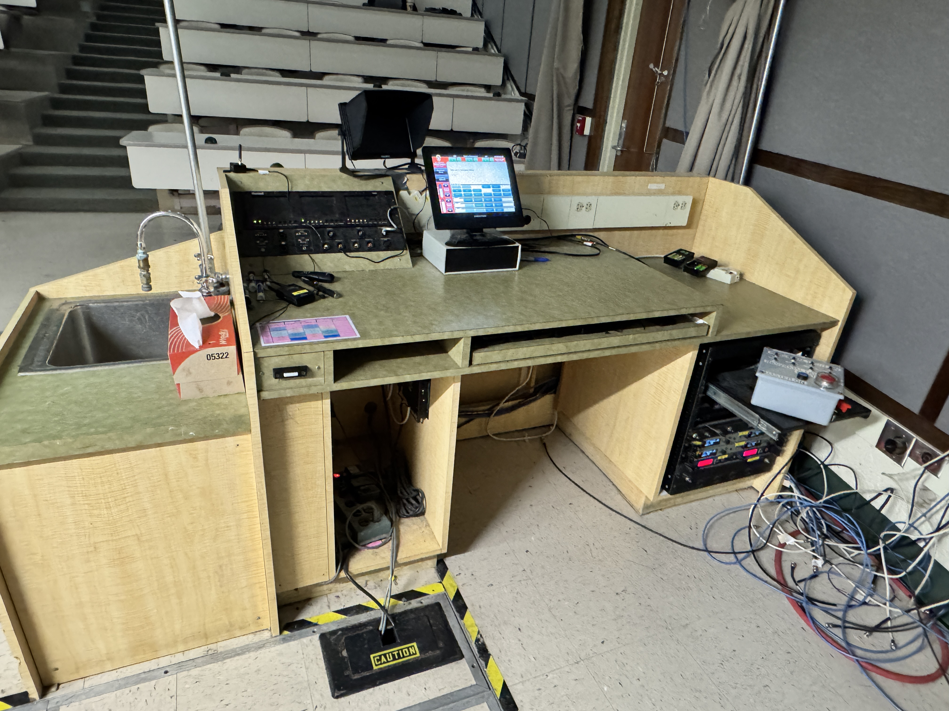Lectern is not removable, contains a sink with running water. (Same as room 2241 & room 2223) {Oh yeah, this room has a doorbell Panic button via cat5}
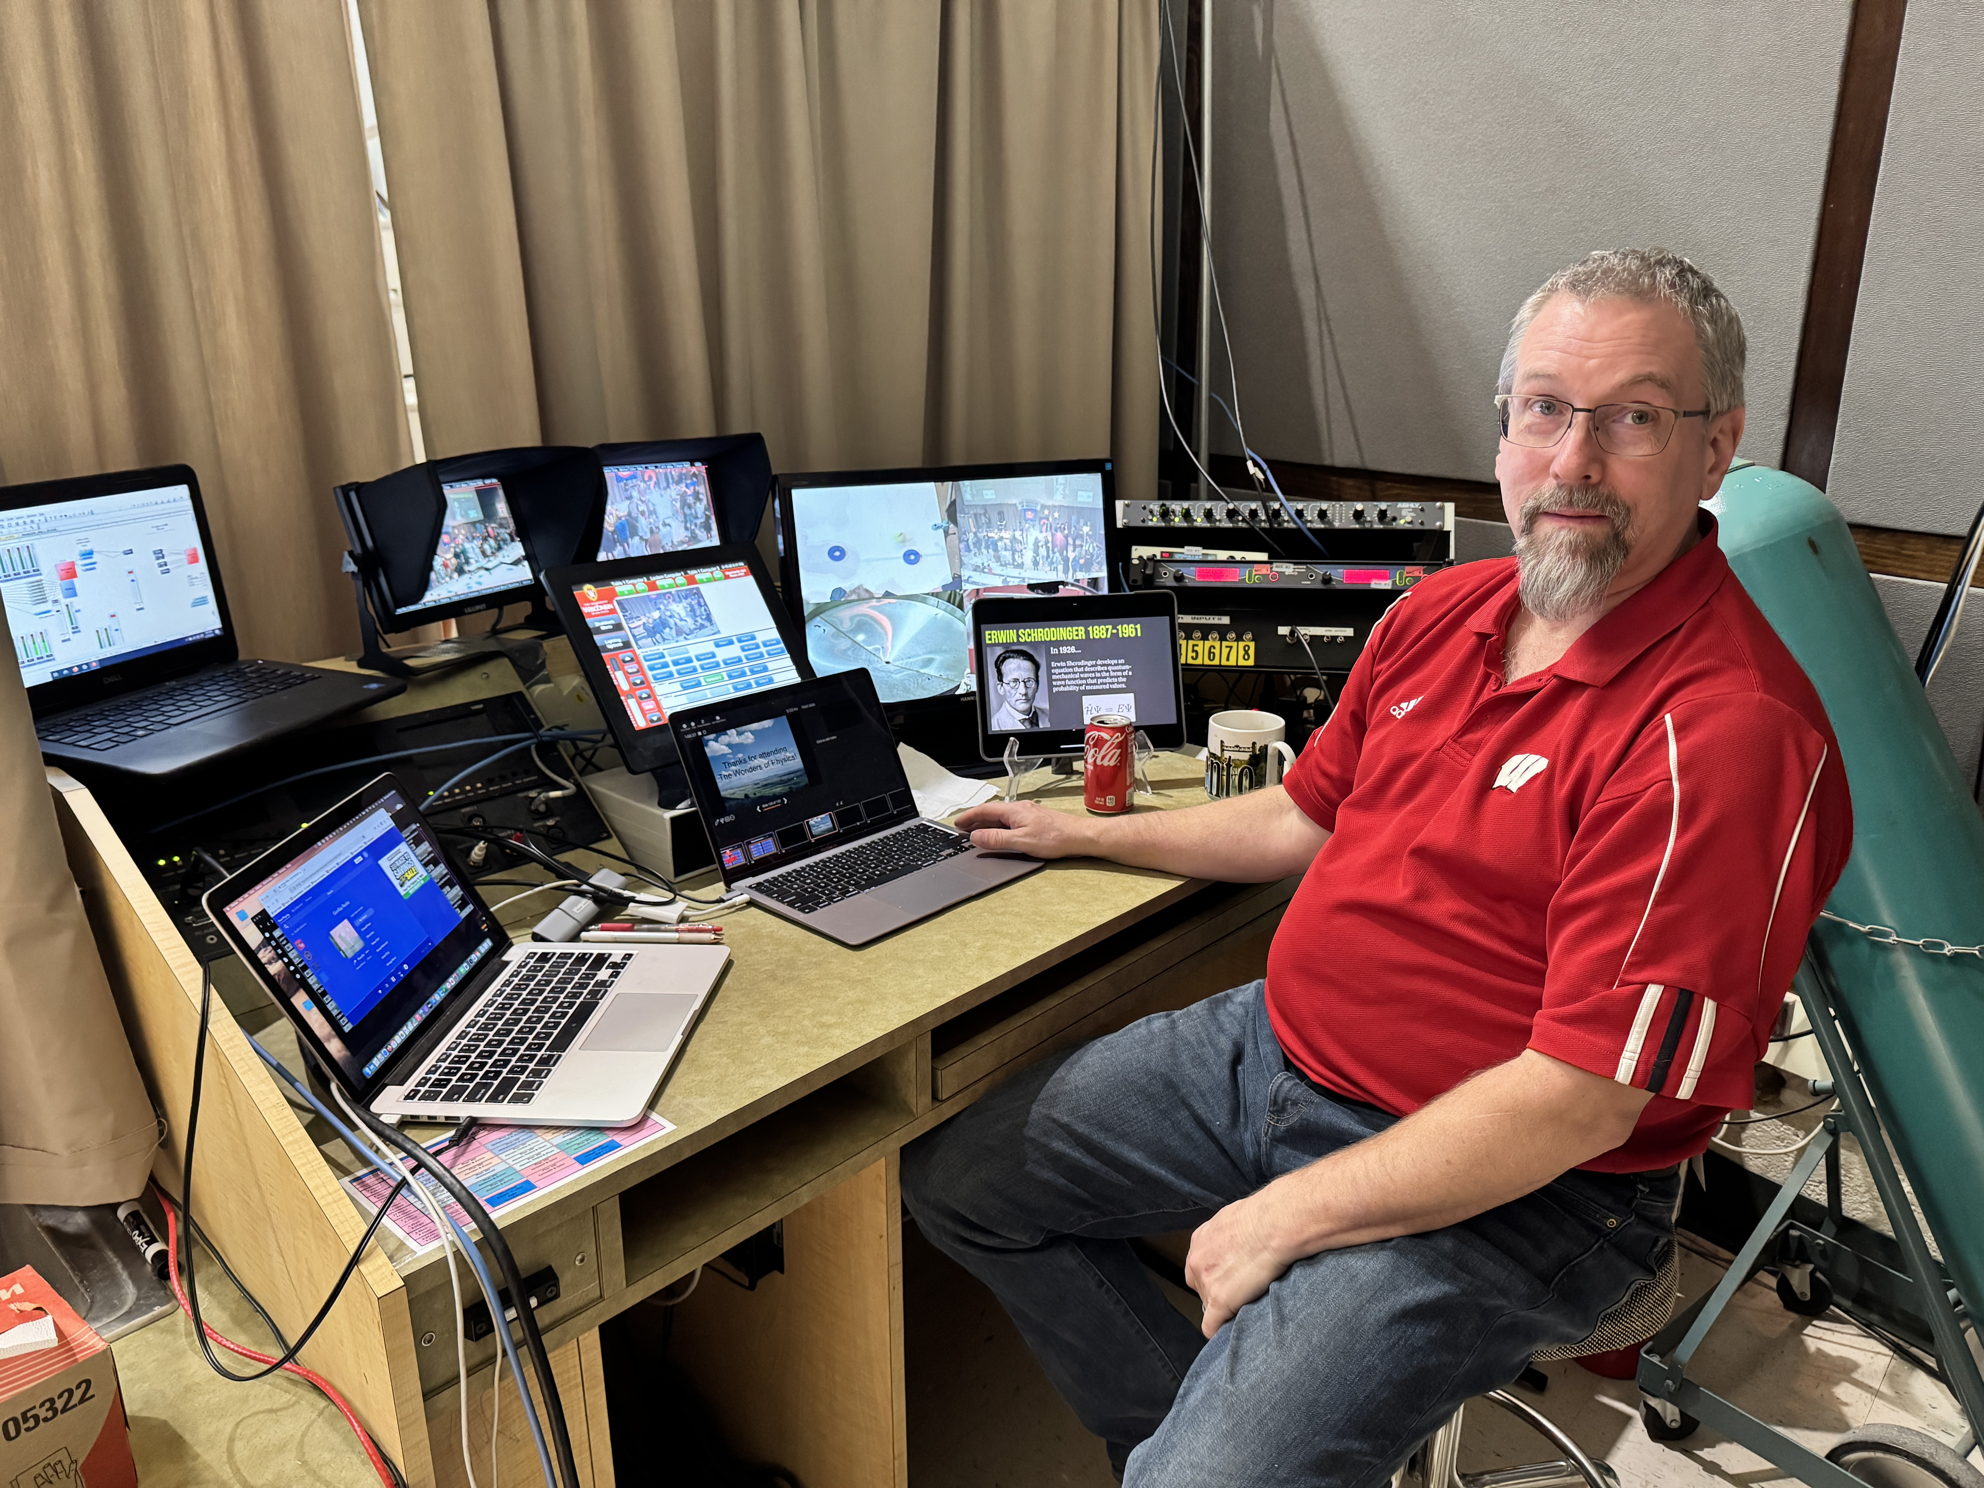A typical Wonders of Physics lectern setup to run the annual show.

Three computers, iPad, more microphones, multi viewer, stage lights control box, and camera controls

Room 2223:
General Needs:
- 2 projectors are a must (both must have video mute and freeze capabilities).
- Writing surface is also necessary (Magnetic glass whiteboard is preferred by our department) with new lights.
- With the new writing surfaces (glass), we will need 2 robotic screens that are preferably recessed within the ceiling cavity for the projectors and should be integrated with the controls.
- Glass board writing surface will require better illumination that does not interfere with the projection screens.
- (Off the cuff – This room would be great for a large digital interactive touchscreen video wall system, one that you can write on. Contact me about my ideas. )
- Must have 2 ceiling cameras (one in the back and one above tables).
- It would be extraordinarily beneficial to have the camera that is over the lecture demonstration tables mechanically move along a track that is directly above and centered on the table system below.
- This room typically holds our acoustics course(s) which requires full range full dynamic speakers, which are currently within the room.
- There is no utility/cable conduit(s) from room 2223 lectern to the control room 2237.

Lectern Needs:
- Two computer input ports HDMI or USBC. (USB-C cable should be powered)
- One video w/stereo audio input port.
- At least 2 USB-C charging ports within the power wire molding.
- At least 1 airplay port to display wirelessly (or some other “reliable” wireless system) – Currently using Apple TV.
- Lecture capture system for general assignment primarily.
- Total control of the system: input signals, source, PTZ camera, & data location from the control room 2237 as well as from the lectern. – Currently there is no remote capabilities to control the room.
- Touch screen console for controlling the AV system must have graphic preview for all inputs.
- Document camera when needed.
- Audio input (XLR) & audio output for Zoom sessions (mono 1/8 phono or USB converter).

Removable Demonstration Table system:
- This room as 2 older style bench tables, currently labeled as Table. They do not, as of yet, contain black utility racks underneath, but do support lecture demonstrations and audio/video needs as one table node. Eventually, these benches will be replaced with the current setups that is being used in rooms 2241 & 2103.
- Thus, only one table node needed in this room
- Must have 2 computer input ports, HDMI is preferred but also can handle VGA
- 2 Camera input port for portable box cameras that use NTSC, SDI, or HDMI for their output.
- Audio input points (left and right channel).
- XLR audio output.
Please note this room is above a physics laboratory with a honeycomb ceiling and duct work, so running new conduit may be an issue.

Room 2237 photos:
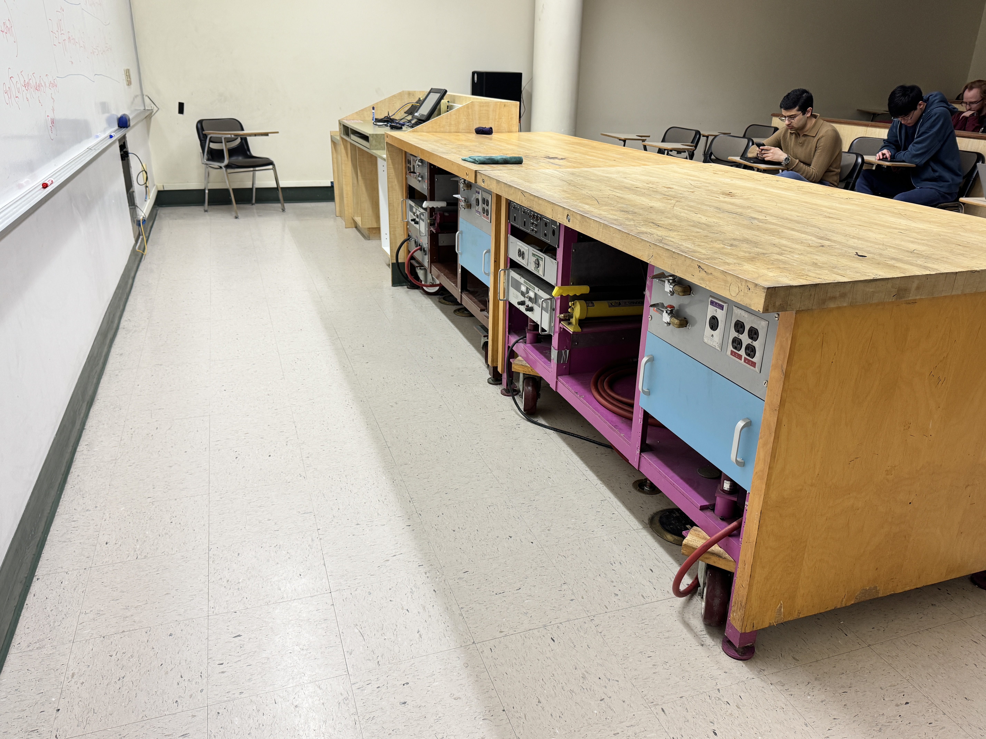Removable demo tables and
