vMix – 4K or --HD | 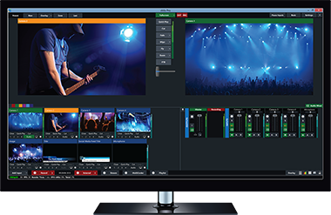 | $700 | $350
Blackmagic DeckLink Quad 2 - Video capture adapter - PCIe x8 | 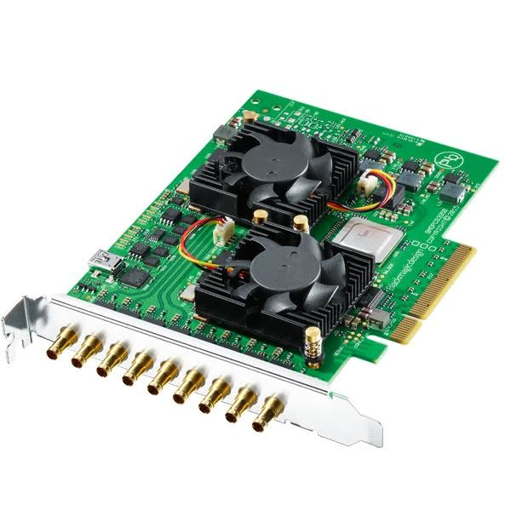 | $995
B&H Photo AV
Or Markertek
Lumantek HDMI/VGA to SDI EZ-Converter with Scaler | 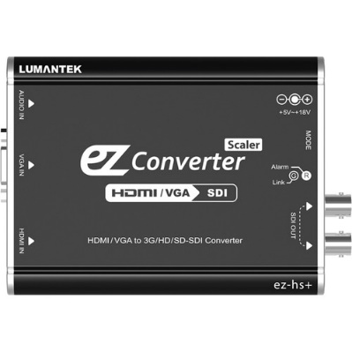 | $269 Each
 |  | Need 3 to replace Tie-lines (Scan Converters)
 |  | B&H Photo AV
Blackmagic Design Micro Converter HDMI to SDI | 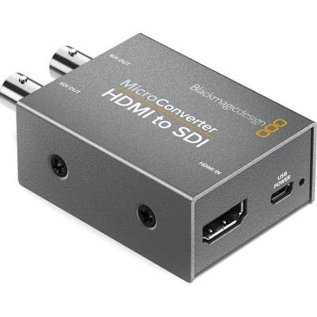 | $39 Each
 |  | Need 14 – to convert all room cameras to SDI
 |  | B&H Photo AV
19 Pin HDMI Male to HDMI Male Adapter | 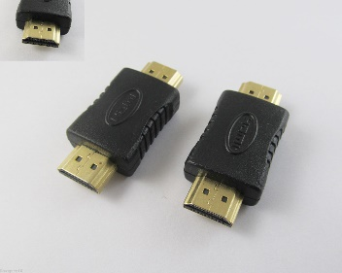 | ($1.30 - $3)
 |  | Need 12 – to Couple AV2 to SDI converters together
 |  | All Over, Ebay - Amazon
Composite AV2HDMI Converter 1080P | 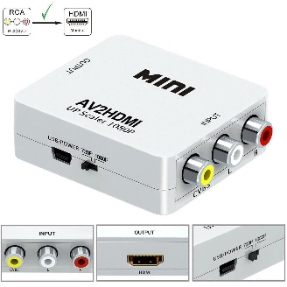 | $4 (Cheapest)
 |  | Need 12 – To convert all room cameras to HDMI
 |  | EBay
Shinybow 1 x 4 Composite Video Distribution Amplifier | 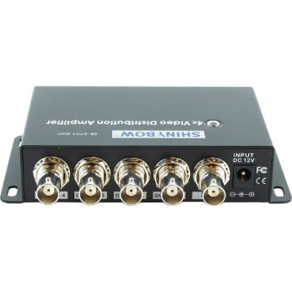 | $57 Each
 |  | Need around 10 of them to spit the rest of the camera’s output to convert to SDI
 |  | B&H Photo AV
VeLLBox SDI Switcher 4x1, 4 In 1 Out SDI Switcher, Support Resolution up to 1080p | 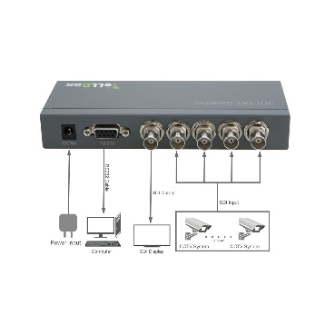 | $119. Each
 |  | Need 2 – One for 2241 outputs and one for 2103 Outputs
 |  | Amazon
Samsung 40" Class FHD (1080P) LED TV (UN40H5003BFXZA) | 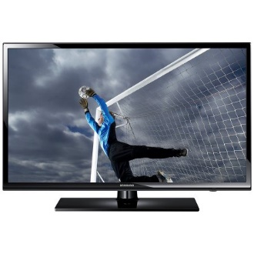 | Around $230
 |  | For control room Multiviewer and pre-view for recording lectures in either room (2241,2223,2103)
 |  | Anywhere
Blackmagic MultiView 16 Video Multiviewer for 16-Channels of SDI | 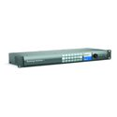 | $1495
For control room Multiviewer and pre-view for recording lectures in either room (2241,2223,2103)
(“Smith’s Page” ??)
 |  | Markertek
YaeKoo CCTV joystick Keyboard Controller LCD Display for PTZ Speed Dome Camera control | 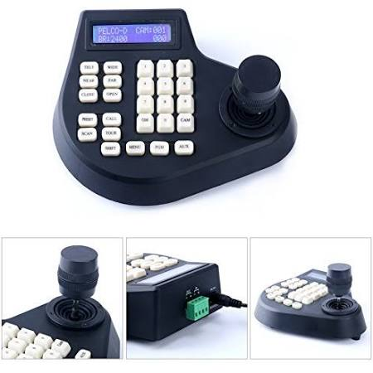 | $53
Need only 1
Control cameras once we concert to RS485 from RS232
 |  | Amazon
Total: $5723

(41+ power supplies)

