vMix – 4K  - New Computer Motor is needed | 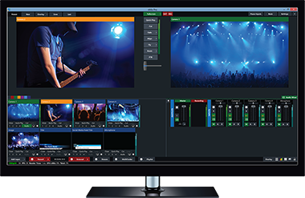 |  |  |  |  | $700
Replaces:
- Focus MX4 Video Switch
- 2 Monitors
- Pinnacle Studio
Blackmagic DeckLink Quad 2 - Video capture adapter - PCIe x8  - New Computer Motor is needed | 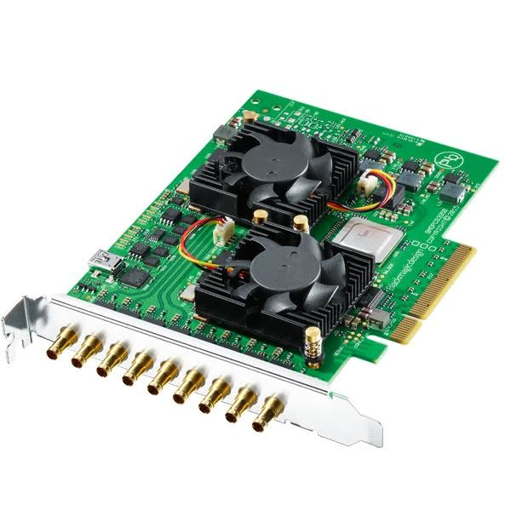 |  |  |  |  | $995
B&H Photo AV
Or Markertek

Replaces:
- Dazzle 1ch input
2 card 5ch Option:
- Blackmagic DLDUO2 DeckLink Duo 2 $495.
- Blackmagic DeckLink Mini Monitor SD/HD PCI-E Card $145.
- $640 to $990
Smart Videohub  2 40x40  Advanced 40 x 40 multi format SD, HD and Ultra HD SDI router with built in video monitoring, spin knob control, and 6G-SDI technology.  Only because all video lines are with both rooms. The control room is the 2nd dairy user | 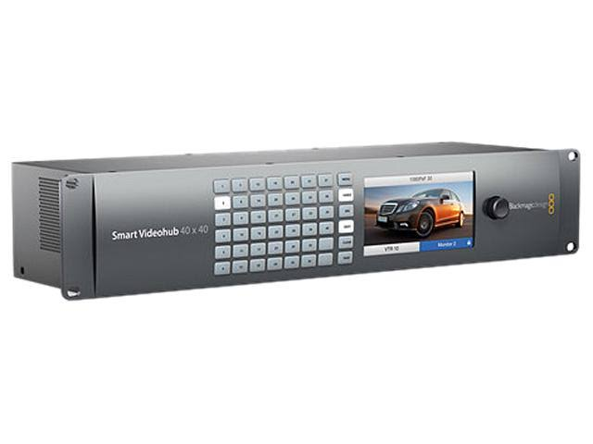 |  |  |  |  | $2995. – 40x40  $2995. - $40x40
Replaces :
- 95% of Patchbay
- CR Video Router
- CR RGB Router
- 3 Scan Converters
- 4 Video DA’s
 |  |  |  |  |  | B&H Photo AV
 |  |  |  |  |  | Sub Total: $5990.
YaeKoo CCTV joystick Keyboard Controller LCD Display for PTZ Speed Dome Camera control | 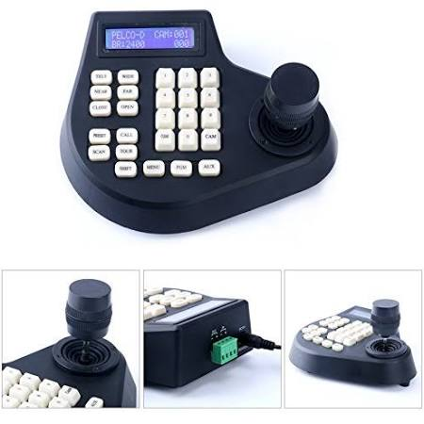 |  |  |  |  | $53
Need only 1
Control cameras once we concert to RS485 from RS232

Adds:
- Camera Controls

 |  |  |  |  |  | Amazon
Samsung Monitors | 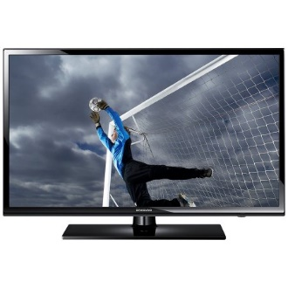 |  |  |  |  | - ~ $450  - ~ $550  - ~ $160
- CR Multiviewer  - UN50MU6070F  - CR Computer  - LU32H850U MNXZA 31.5”  - 2103 preview  - SD300 21.5” |  |  |  |  |  | For control room Multiviewer and pre-view for recording lectures in either room (2241,2223,2103)  Replaces  - All CR monitors  Adds  - more views  - 1st step towards the “Smith Page”
 |  |  |  |  |  | Anywhere
 |  |  |  |  |  | Sub Total: $1160.
Blackmagic MultiView 16 Video Multiviewer for 16-Channels of SDI | 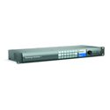  “Smith Page” will require a 2nd unit, which can be smaller. |  |  |  |  | $1495
Replaces
- All CR monitors
Adds
- more views
- 1st step towards the “Smith Page”

 |  |  |  |  |  | B&H Photo AV
 |  |  |  |  |  | Total: $10393.
Crestron Digital Media(DM) Items to “Update”
Rooms 2241, 2223, 2237, and 2103 to match room 2103 HD capabilities. Plus expanding the video bridge to digitally (HD) record any lecture within these rooms or bridge the rooms for overflow.
{Most everything is now on eBay (used and new)}
Crestron DM-MD32X32 | 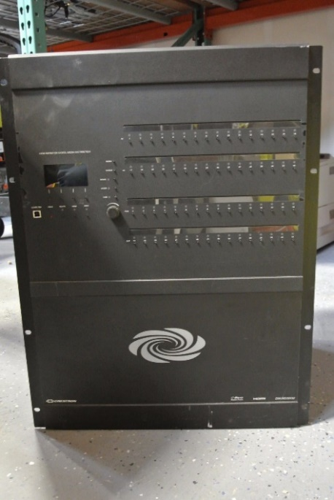 |  |  |  |  | MSRP - $18400  A+ Price - $11500
eBay
$3500 - $7000
 |  |  |  |  |  | Need 1 unit
 |  |  |  |  |  | ~ $5500
Crestron Pro3 Series Advanced Control Processor  May need additional com port card(s) | 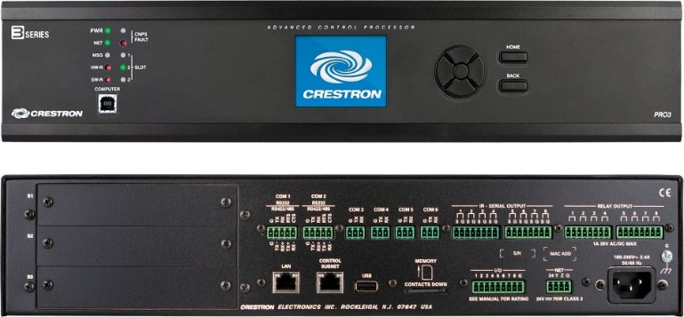 |  |  |  |  | MSRP - $5300.  A+ Price - $3300.
eBay
$200 to $5600
 |  |  |  |  |  | Need 1 unit
 |  |  |  |  |  | $2500
DMC-C-DSP DigitalMedia 8G+ Input Card | 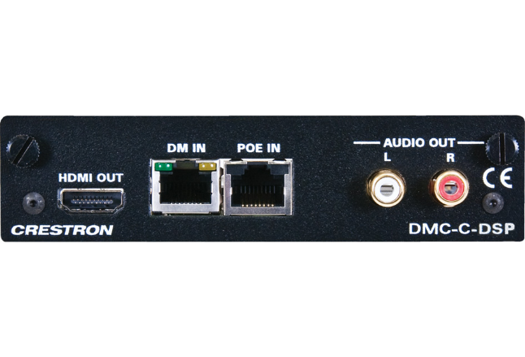 |  |  |  |  | Discontinued  Replacement DMC-4K-C-DSP-HDCP2 ( $815) A+
eBay
$75 - $150 {125}
Need:  - 8 for 2241  - 5 for 2223  - 2 for 2103  - 2 for CR |  |  |  |  |  | Need 17
Sub Total: $1500
To $2300.
Blackmagic Design Mini Converter HDMI to SDI 4K | 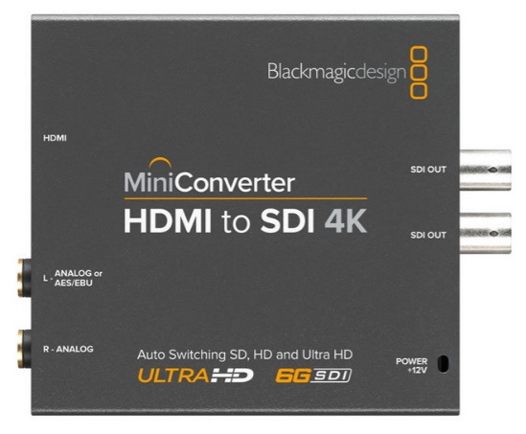 |  |  |  |  | $265 Each up to $300
 |  |  |  |  |  | Need 10 to replace and add Tie-lines
Need:  - 4 for 2241  - 4 for 2103  - 3 for 2223 |  |  |  |  |  | Full Compass
 |  |  |  |  |  | Sub Total: $3000
DMC-SDI Input Card | 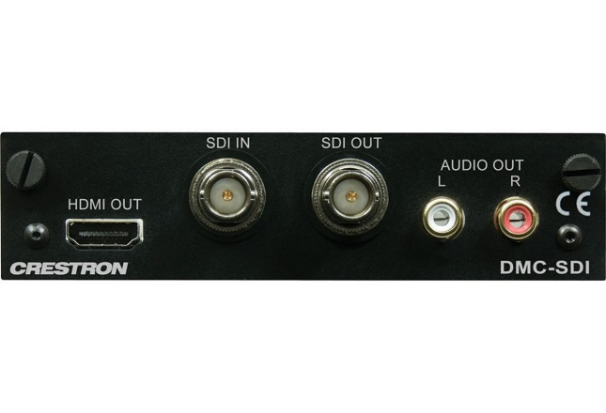 |  |  |  |  | MSRP - $1200  A+ Price - $750
eBay
~$150
Need:  - 8 for 2241  - 4 for 2223  - 8 for 2103 |  |  |  |  |  | Will need at least 20 cards
 |  |  |  |  |  | Sub Total: $3000
DMCO-33 output Card  Or Equivalent | 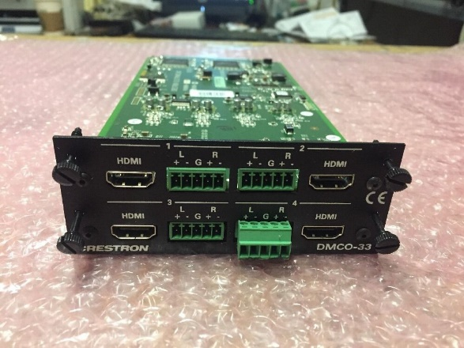 |  |  |  |  | Discontinued
eBay
~$200
Need:  - 1 for 2241  - 1 for 2223  - 2 for Smithpage |  |  |  |  |  | Need 4 card
 |  |  |  |  |  | Sub Total: $800
DMCO-55 Digital Media Output Card  Or Equivalent | 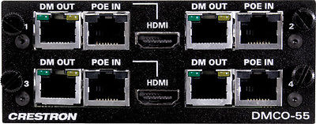 |  |  |  |  | Discontinued
eBay
~$400. - $500.
Need:  - 1 for 2241  - 1 for 2237 |  |  |  |  |  | Need 2
 |  |  |  |  |  | Sub Total: $1000
Steaming Card  DMCO-77 (Dual output)  Or Equivalent H.264  Maybe difficult to obtain.  Replaced with  DMC-STRO | 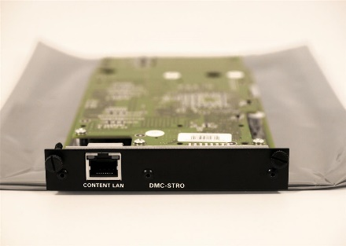 This is the replacement  Looking into other options |  |  |  |  | Discontinued (77)
Not on eBay yet
{500 -1000} Newer Replacement Card
~$800. (stro)
Need 2 ports each:  - for 2241  - for 2223 |  |  |  |  |  | Need 4 (stro) or  2 (DMCO-77)
Sub Total: $1600
To $2000.
Wall Plate DM Transmitter 200 DM-TX-200-2G HDMI | 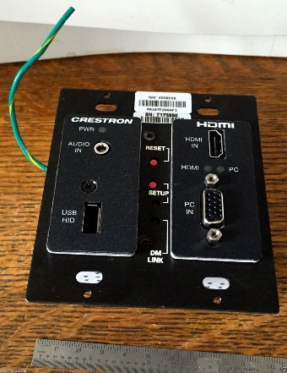 |  |  |  |  | Discontinued
eBay
$40 - $200
Need:  - 5 for 2241  - 3 for 2223  - 1 for 2103  - 1 for 2237 CR |  |  |  |  |  | Need ~10
 |  |  |  |  |  | Sub Total: $900
DM-TX-201-C | 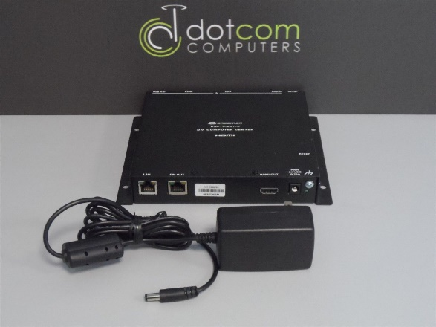 |  |  |  |  | MSRP - $1300  A+ Price - $813
eBay
$40 - $300
Need:  - 3 for 2241  - 2 for 2223  - 1 for 2103 |  |  |  |  |  | Need 6
 |  |  |  |  |  | Sub Total: $1200
Touch Screens for 2241,2237, & 2223  Plus:  Cable V-CBL-S6-B  Is needed  24Vdc, 2A Power Supplies maybe needed.  2223 doesn’t need video preview. TSW-1050 would work or perhaps one of our older units. Up to programmer… | 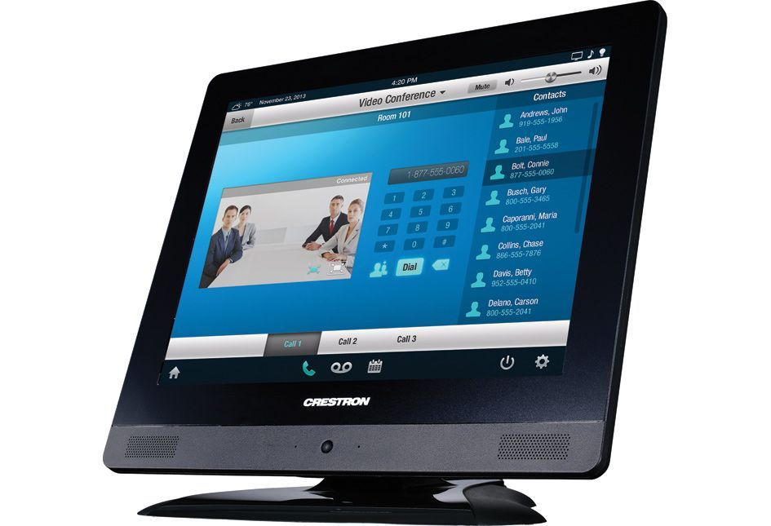 |  |  |  |  | Discontinued
eBay
$160 - $480
Need 3
- 2241
- 2237
- 2223
 |  |  |  |  |  | Sub Total: $1500
TPMC-V-IMCW  Power supplies maybe needed | 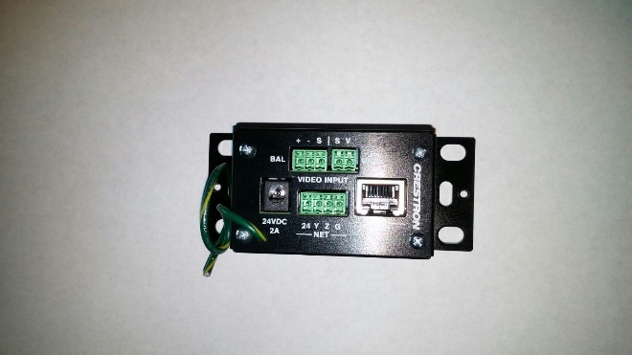 |  |  |  |  | Discontinued
eBay
$15 - $100
 |  |  |  |  |  | Need 3
 |  |  |  |  |  | Sub Total: $150
DM-RMC-SCALER-C | 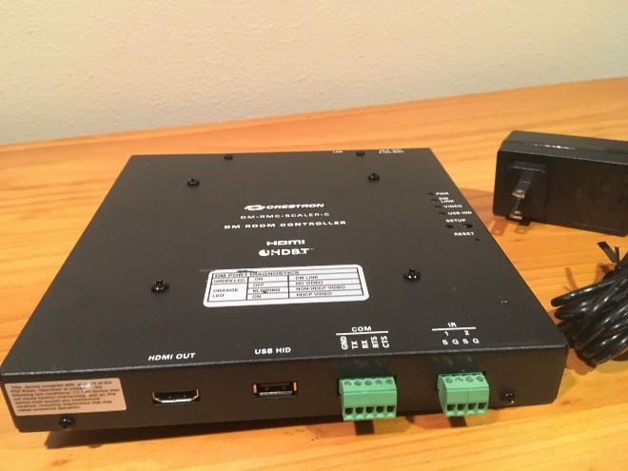 |  |  |  |  | MSRP $1400  A+ Price 875
eBay
$30 - $100
Need 5  - 3 in 2241  - 2 in 2223 |  |  |  |  |  | Need 5  - Projectors
 |  |  |  |  |  | Sub Total: $500
1000’ of CAT 6a shielded  Plus:  Tips are needed | 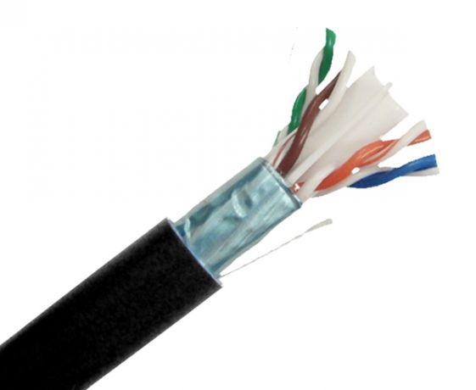 |  |  |  |  | $160 -$280 each
At least 9 runs to rm 2241 (~1600’)
At least 6 runs to 2223 (~300’)
 |  |  |  |  |  | Need around 1900’
 |  |  |  |  |  | Sub Total: ~$400
 |  |  |  |  |  | Total: $23,850.
 |  |  |  |  |  | Grand Total: $33,243.
Rough Cast for 2241 |  | Rough Cast for control room |  | Update 2103 to SDI | Upgrade of 2223 plus  Extra functions for all rooms.
$17,645. |  | $3,258. |  | $5,995. | $6,345.
Misc. Other Items:
VeLLBox SDI Switcher 4x1, 4 In 1 Out SDI Switcher, Support Resolution up to 1080p | 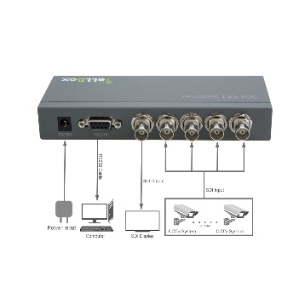 |  |  |  |  | $119. Each
 |  |  |  |  |  | Need 2 – One for 2241 outputs and one for 2103 Outputs
 |  |  |  |  |  | Amazon
Need only 1
Control cameras once we concert to RS485 from RS232
 |  |  |  |  |  | Optional, Not sure if it’s needed yet.
Blackmagic Design CONVMCAUDS  Audio to SDI Mini Converter | 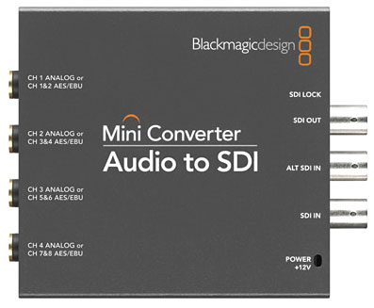 |  |  |  |  | ~ 195 each
 |  |  |  |  |  | B&H Photo AV
Need Unknown
Maybe 2 or 4

