Updating Room 2103

Crestron Digital Media(DM) Items to “Update Room 2103”
To room 2103 HD capabilities up to digital (SID) & 6G/4K output.

{Most everything is now on eBay (used and new)}
DMC-C-DSP DigitalMedia 8G+ Input Card | 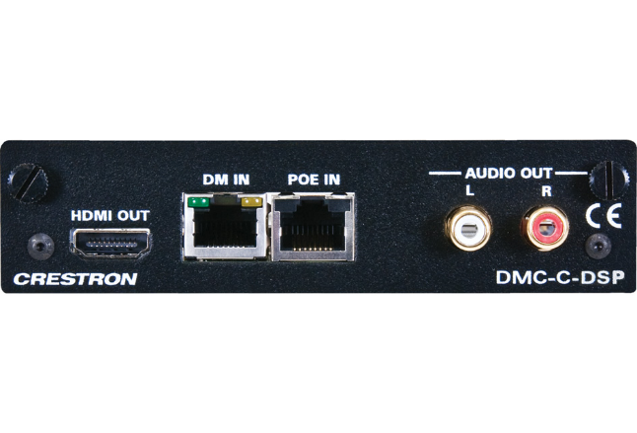 |  |  |  |  | Discontinued  Replacement DMC-4K-C-DSP-HDCP2 ( $815) A+
eBay
$100 - $200
Need:  - 3 for 2103 |  |  |  |  |  | Need 3
 |  |  |  |  |  | Sub Total: $375
DMC-HD-DPS or  DMC-4K-HD-HDCP2 | 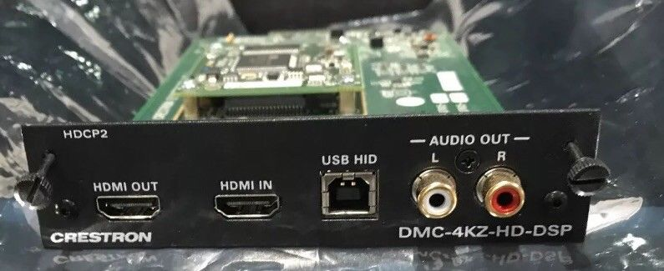 |  |  |  |  | {4k-HD card}  MSRP - $800  A+ Price - $500
 |  |  |  |  |  | Ebay: $100 - $500
Need:  - 3 for 2103 |  |  |  |  |  | Need 3
 |  |  |  |  |  | Sub Total: $750
DMC-SDI Input Card | 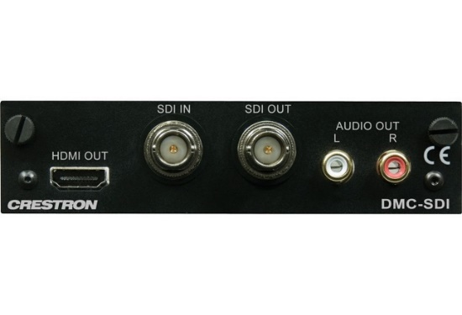 |  |  |  |  | MSRP - $1200  A+ Price - $750
eBay
~$150
{HOT Ebay Item}
Need:  - 8 for 2103 |  |  |  |  |  | Will need at least 8 cards
 |  |  |  |  |  | Sub Total: $1200
Replace DMCO-33 output Card  With  DMC-4K-HDO | 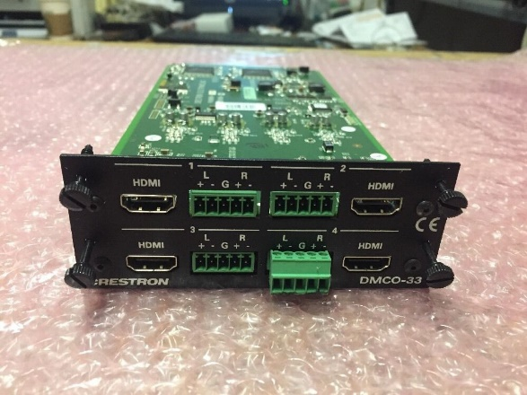  then demote the old card to the Smithpage
eBay
$100 - $500

$400 - $600 4K-HD

Need:  - 1 for 2103 for Smithpage |  |  |  |  |  | Need 1 card
 |  |  |  |  |  | Sub Total: $600
Blackmagic Design BMD-CONVMBHS24K6G Mini Converter - HDMI to SDI 6G | 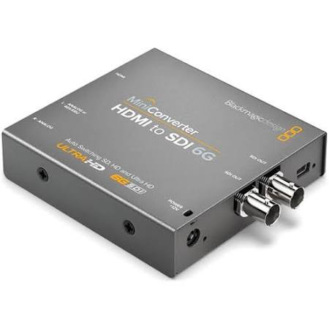 |  |  |  |  | Current
Markertek
$145.

Need:  - 4 for 2103  - Video Hub Tie in lines.  - Converts HDMI to SDI |  |  |  |  |  | Need 4
 |  |  |  |  |  | Sub Total: $580
Steaming Card  DMCO-77 (Dual output)  Or Equivalent H.264  Maybe difficult to obtain.  Replaced with  DMC-STRO | 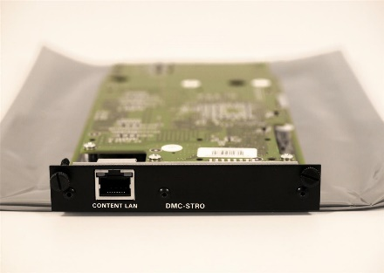 This is the replacement  Looking into other options  OPTIONAL !!! |  |  |  |  | Discontinued (77)  Not on eBay yet
Replacement Card
(DMCO -stro)
MSRP - $3000
A+ Price - $1875

Ebay (~800. & Up)
Need 2 ports each:  - for 2103 |  |  |  |  |  | Need 2 (stro) or  1 (DMCO-77)
 |  |  |  |  |  | Extra: $1600
Wall Plate DM Transmitter 200 DM-TX-200-2G HDMI | 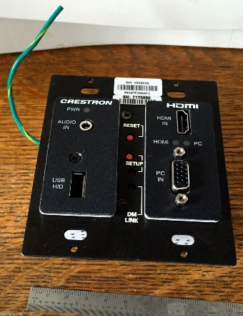 |  |  |  |  | Discontinued
eBay
$40 - $200
Need:  - 1 for 2103, Need to replace an existing one |  |  |  |  |  | Need 1
 |  |  |  |  |  | Sub Total: $75
DM-TX-4K-100-C-1G-B-T | 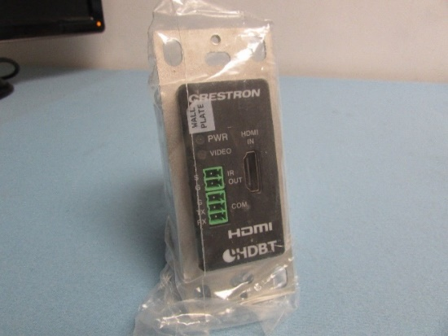 |  |  |  |  | MSRP - $700  A+ Price - $438
eBay
$125 - $300
Need:  - 3 for 2103  - On Lectern for Doc. Cam and 2 apple iTV’s |  |  |  |  |  | Need 3
 |  |  |  |  |  | Sub Total: $500
Replace DMCO-55 Card with 2 @ 4KZ-CO-HD | 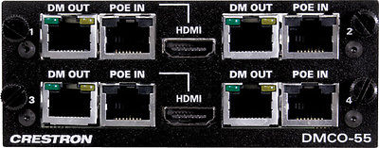 |  |  |  |  | Discontinued
eBay
~$400. - $500.
Need:  - 3 outputs |  |  |  |  |  | Need 2  “new cards”
 |  |  |  |  |  | Sub Total: $500+
Replace old Scalers with DM-RMC-4K-SCALER-C  DM-RMC-SCALER-C  Is cheaper but can’t handle 4K | 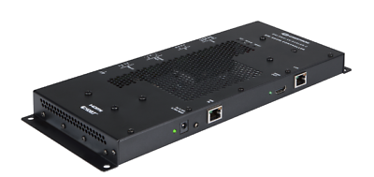  If we buy this for 2103, we can reuse the old ones within room 2223 and save $200. + |  |  |  |  | MSRP $1800  A+ Price 1125
eBay
$400-900
Need 3  - 3 in 2103 |  |  |  |  |  | Need 3  - Projectors
 |  |  |  |  |  | Sub Total: $1500
600’ of CAT 6a shielded  Plus:  Tips are needed | 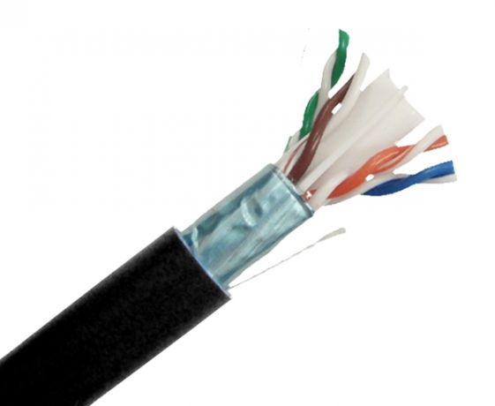 |  |  |  |  | $180 -$280 each
 |  |  |  |  |  | At least ~3 runs to rm 2103 (~600’)
 |  |  |  |  |  | Need around 1/2 spool
 |  |  |  |  |  | Sub Total: ~$175
 |  |  |  |  |  | Total: $6,255.
Rough Cast for rm2241 to SDI and to 6G/4K output |  | Rough Cast for control room to SDI and to 6G/4K |  | Update rm2103 to SDI and to 6G/4K output | Rough Cast for rm2223
$21,565. |  | $9,195. |  | $6,255. | $4,015.
Misc. Other Items:
XtremPro 61035 HDMI 4x1 Quad Multi-Viewer | 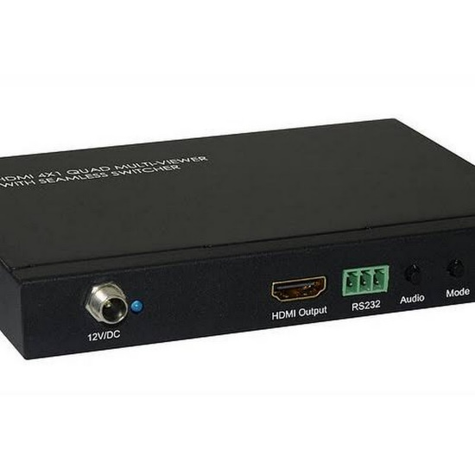  “Smith Page” will require a unit like this one. |  |  |  |  | $149
 |  |  |  |  |  | - “Smith Page”

