ADDING ROOM 2223
Crestron Digital Media(DM) Items to “Update Room 2223”
To match room 2103 capabilities, record or bridge the rooms for overflow will be simplified.
{Most everything is now on eBay (used and new)}
DMC-C-DSP DigitalMedia 8G+ Input Card | 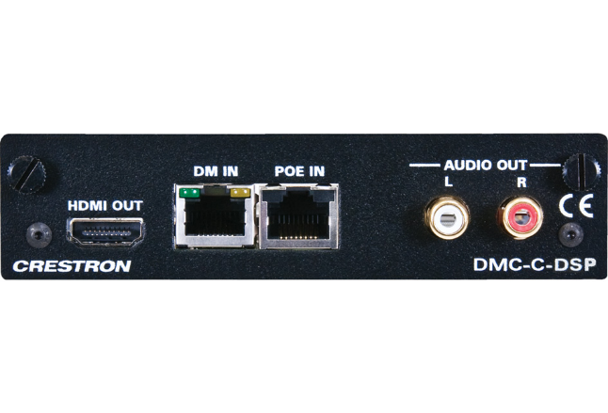 |  |  |  |  | Discontinued  Replacement DMC-4K-C-DSP-HDCP2 ( $815) A+
eBay
$100 - $200
Need:  - 5 for 2223 |  |  |  |  |  | Need 5 Cards
 |  |  |  |  |  | Sub Total: $625
DMC-SDI Input Card | 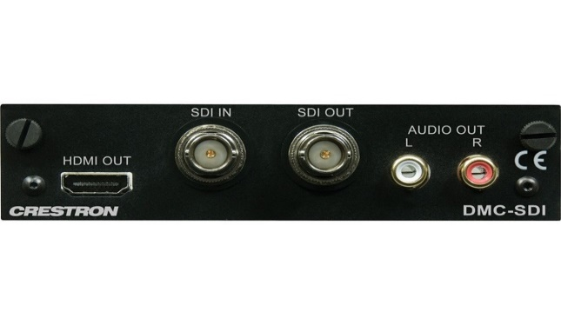 |  |  |  |  | MSRP - $1200  A+ Price - $750
eBay
~$150
{HOT Ebay Item}
Need:  - 4 for 2223 |  |  |  |  |  | need 4 cards
 |  |  |  |  |  | Sub Total: $600
DMCO-33 output Card  Or Equivalent  DMC-4K-HDO (Is preferred) | 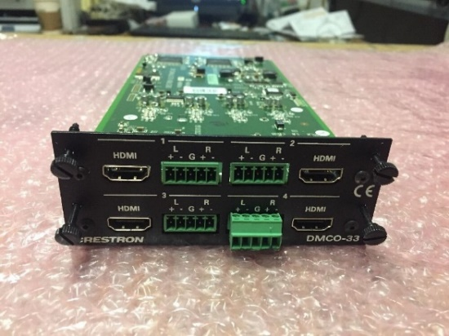 |  |  |  |  | Discontinued
eBay
$100 - $500

$400 - $600 4K-HD

Need:  - 1 for 2241 |  |  |  |  |  | Need 1 card
 |  |  |  |  |  | Sub Total: $600
DMCO-55 Digital Media Output Card  Or Equivalent  4KZ-CO-DH (Is preferred | 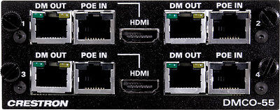 |  |  |  |  | Discontinued
eBay
~$400. - $1000.

Need:  - 1 for 2223 |  |  |  |  |  | Need 1 for Projector
 |  |  |  |  |  | Sub Total: $500
Optional:  Steaming Card  DMCO-77 (Dual output)  Or Equivalent H.264  Maybe difficult to obtain.  Replaced with  DMC-STRO | 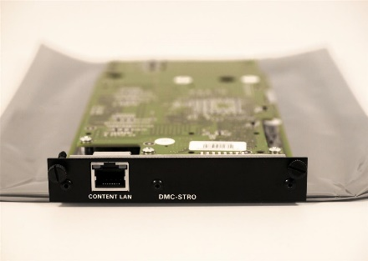 This is the replacement  Looking into other options |  |  |  |  | Discontinued (77)  Not on eBay yet
Replacement Card
(DMCO -stro)
MSRP - $3000
A+ Price - $1875

Ebay (~800. & Up)
Need 2 ports each:  - for 2223 |  |  |  |  |  | Need 2 (stro) or  1 (DMCO-77)
 |  |  |  |  |  | Extra: $800
Wall Plate DM Transmitter 200 DM-TX-200-2G HDMI | 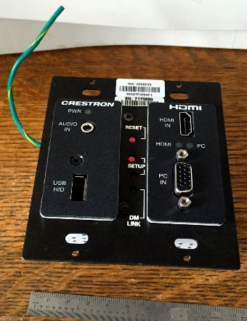 |  |  |  |  | Discontinued
eBay
$40 - $200
Need:  - 2 for 2223 |  |  |  |  |  | Need 2
 |  |  |  |  |  | Sub Total: $150
DM-TX-4K-100-C-1G-B-T | 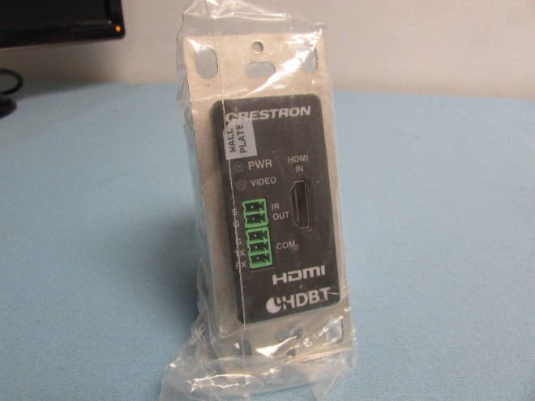 |  |  |  |  | MSRP - $700  A+ Price - $438
eBay
$125 - $300
Need:  - 1 for 2223  - On Lectern |  |  |  |  |  | Need 1
 |  |  |  |  |  | Sub Total: $150
DM-TX-201-C | 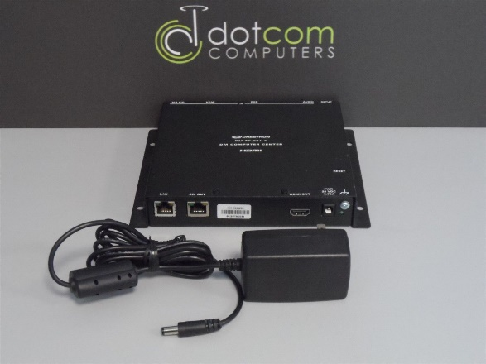 |  |  |  |  | MSRP - $1300  A+ Price - $813
eBay
$25 - $150
Need:  - 2 for 2223  - On Lectern |  |  |  |  |  | Need 2
 |  |  |  |  |  | Sub Total: $150
Blackmagic Design Mini Converter HDMI to SDI 6G  Need:  - 3 for 2223 | 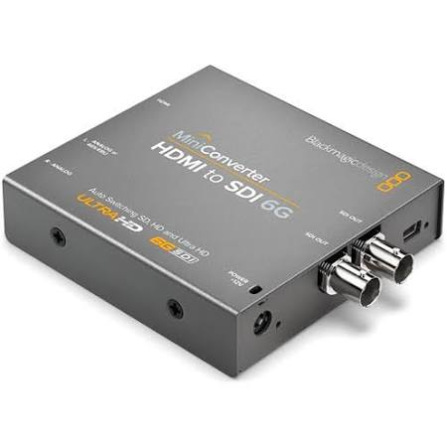 |  |  |  |  | $145 Each
 |  |  |  |  |  | Need 4 to replace and add Tie-lines
 |  |  |  |  |  | Full Compass
 |  |  |  |  |  | Sub Total: $435
Touch Screens for 2223  TPMC-V12-Tilt-B  Plus:  Cable V-CBL-S6-B  Is needed  24Vdc, 2A Power Supplies maybe needed.  2223 doesn’t need video preview. TSW-1050 would work or perhaps one of our older units. Up to programmer… | 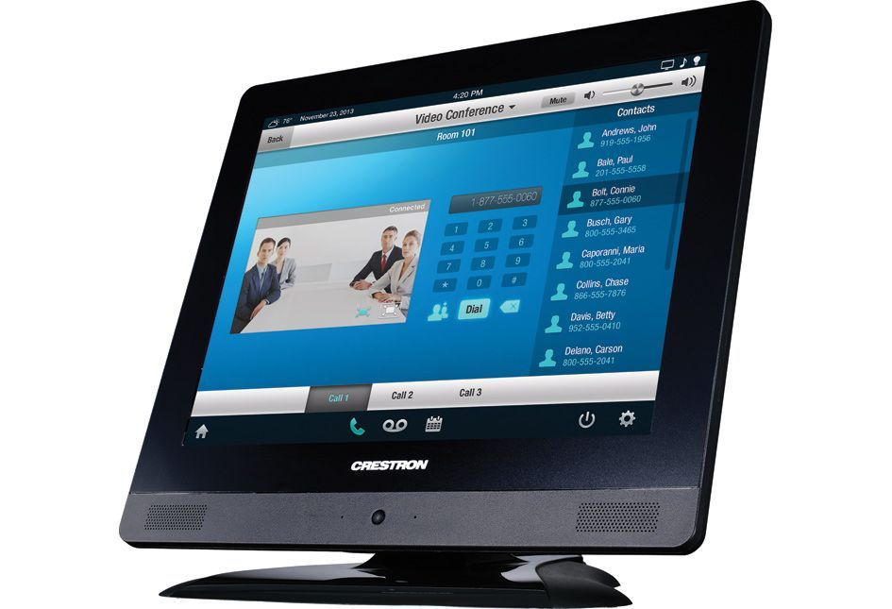 |  |  |  |  | Discontinued
eBay
$200 - $500
Need 1
- 2223

 |  |  |  |  |  | Sub Total: $400
TPMC-V-IMCW  Power supplies maybe needed | 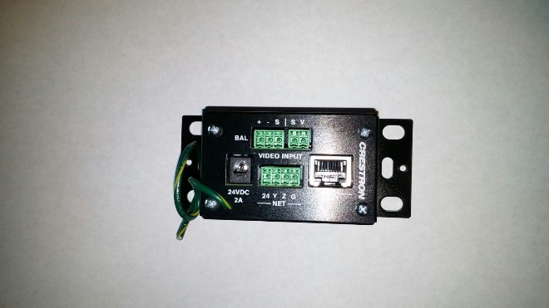 |  |  |  |  | Discontinued
eBay
$15 - $100
 |  |  |  |  |  | Need 1
 |  |  |  |  |  | Sub Total: $30
DM-RMC-SCALER-C  --Could reuse the ones from 2103, if we update that room too. | 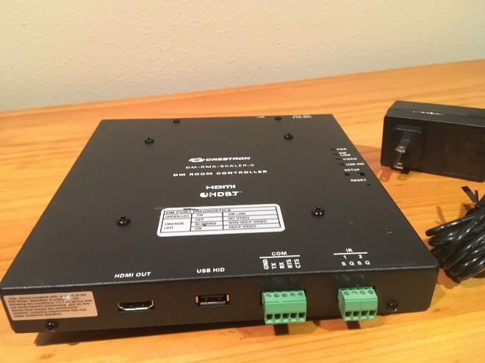 |  |  |  |  | MSRP $1400  A+ Price 875
eBay
$30 - $100
Need:  - 2 in 2223 |  |  |  |  |  | Need 2  - Projectors
 |  |  |  |  |  | Sub Total: $200
500’ of CAT 6a shielded  Plus:  Tips are needed | 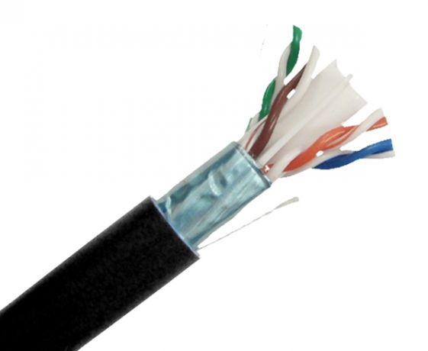 |  |  |  |  | $180 -$280 each
 |  |  |  |  |  | At least 12 runs to rm 2223 (~500’)
 |  |  |  |  |  | Need around 1/2 spool
 |  |  |  |  |  | Sub Total: ~$175
 |  |  |  |  |  | Total: $4,015.
Rough Cast for rm2241 to SDI and to 6G/4K output |  | Rough Cast for control room to SDI and to 6G/4K |  | Update rm2103 to SDI and to 6G/4K output | Rough Cast for rm2223
$. |  | $9,195. |  | $6,255. | $4,015.

