 | Updating the Control ROOM 2237
vMix – 4K  - New Computer Motor is needed | 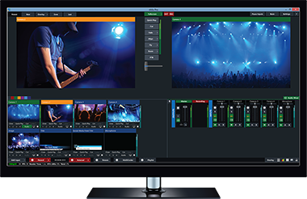 |  |  |  |  | $700
Replaces:
- Focus MX4 Video Switch
- 2 Monitors
- Pinnacle Studio
Blackmagic DeckLink Quad 2 - Video capture adapter - PCIe x8  - New Computer Motor is needed | 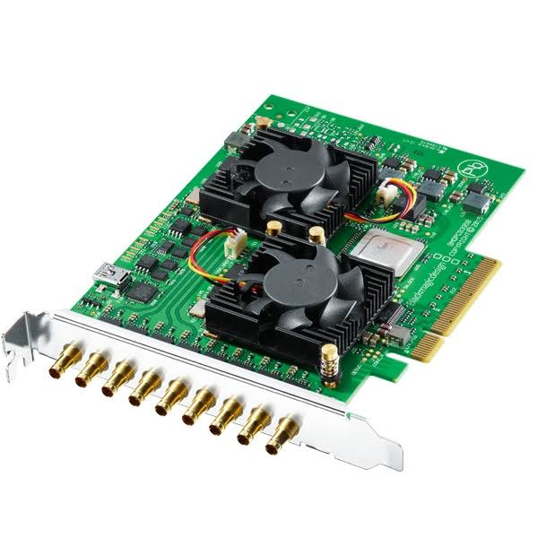
B&H Photo AV
Or Markertek

Replaces:
- Dazzle 1ch input
 |  |  |  |  |  | Sub Total: $995.
Smart Videohub  40x40  Advanced 40 x 40 multi format SD, HD and Ultra HD SDI router with built in video monitoring, spin knob control, and 6G-SDI technology. | 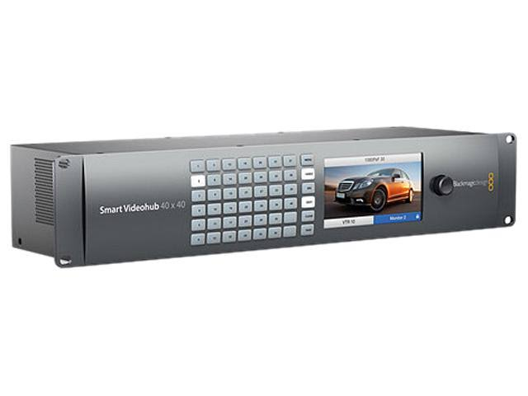 |  |  |  |  | $2995. - $40x40
Replaces :
- Patchbay
- CR Video Router
- CR RGB Router
- 3 Scan Converters
- 4 Video DA’s
 |  |  |  |  |  | B&H Photo AV
 |  |  |  |  |  | Sub Total: $2995.
YaeKoo CCTV joystick Keyboard Controller LCD Display for PTZ Speed Dome Camera control | 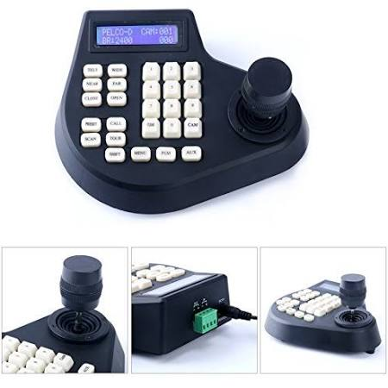 |  |  |  |  | Amazon
Need only 1
Control cameras once we concert to RS485 from RS232

Adds:
- Camera Controls

 |  |  |  |  |  | Sub Total: $60.
Samsung Monitors | 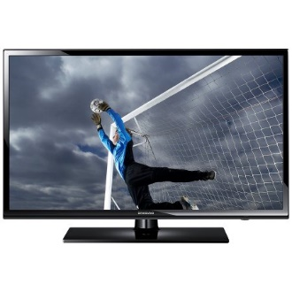 |  |  |  |  | - ~ $450  - ~ $550
- CR Multiviewer  - UN50MU6070F  - CR Computer  - LU32H850U MNXZA 31.5” |  |  |  |  |  | For control room Multiviewer and pre-view for recording lectures in either room (2241,2223,2103)  Replaces  - All CR monitors  Adds  - more views  - 1st step towards the “Smith Page”
 |  |  |  |  |  | Anywhere
 |  |  |  |  |  | Sub Total: $1000.
Blackmagic MultiView 16 Video Multiviewer for 16-Channels of SDI | 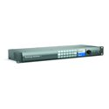  “Smith Page” will require a 2nd smaller unit, which can be HDMI I/O (under $400. Each) |  |  |  |  | $1495
Replaces
- All CR monitors
Adds
- more views
- 1st step towards the “Smith Page”

 |  |  |  |  |  | Sub Total: $1495
DMC-HD-DPS or  DMC-4K-HD-HDCP2 | 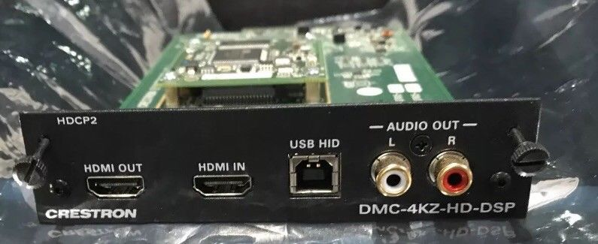 |  |  |  |  | {4k-HD card}  MSRP - $800  A+ Price - $500
 |  |  |  |  |  | Ebay: $100 - $500
Need:  - 2 for 2237 |  |  |  |  |  | Need 2
 |  |  |  |  |  | Sub Total: $400
DM-TX-4K-100-C-1G-B-T | 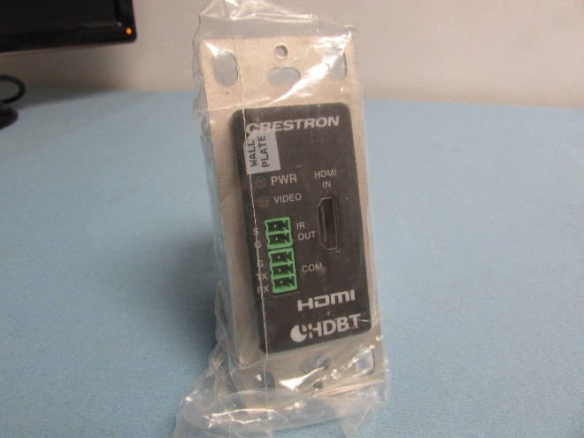 |  |  |  |  | MSRP - $700  A+ Price - $438
eBay
$125 - $300
Need 2 for the
Conferencing Computer

 |  |  |  |  |  | Sub Total: $500
Touch Screens for,2237,  Plus:  Cable V-CBL-S6-B  Is needed  24Vdc, 2A Power Supplies maybe needed.  2223 doesn’t need video preview. TSW-1050 would work or perhaps one of our older units. Up to programmer… | 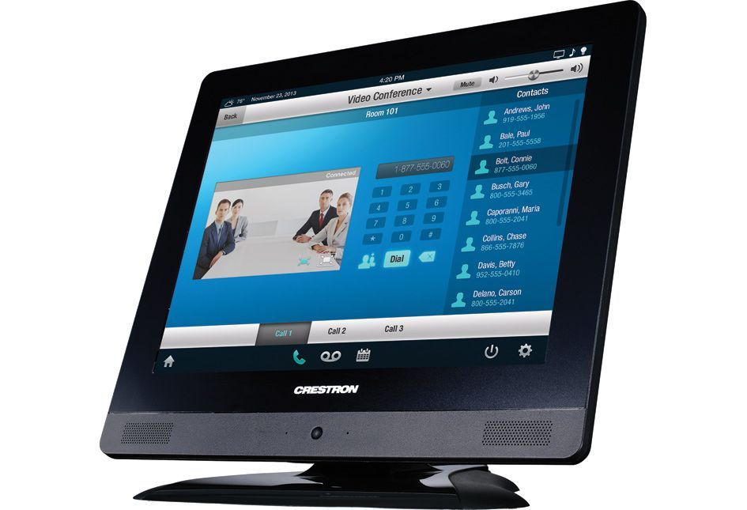 |  |  |  |  | Discontinued
eBay
$160 - $480
Need 3
- 2237

 |  |  |  |  |  | Sub Total: $400
TPMC-V-IMCW  Power supplies maybe needed | 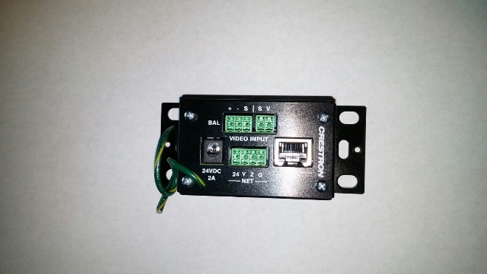 |  |  |  |  | Discontinued
eBay
$15 - $100
 |  |  |  |  |  | Need 1
 |  |  |  |  |  | Sub Total: $50
VeLLBox SDI Switcher 4x1, 4 In 1 Out SDI Switcher, Support Resolution up to 1080p | 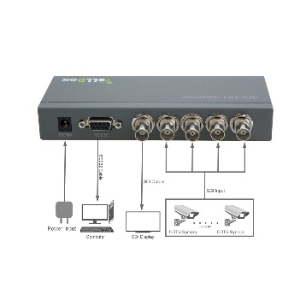 |  |  |  |  | $119. Each
 |  |  |  |  |  | Need 2 – One for 2241 outputs and one for 2103 Outputs
 |  |  |  |  |  | Amazon
Need only 1
Control cameras once we concert to RS485 from RS232
 |  |  |  |  |  | Optional, Not sure if it’s needed yet.
Blackmagic Design CONVMCAUDS  Audio to SDI Mini Converter | 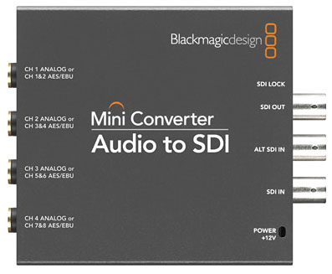 |  |  |  |  | ~ 195 each
 |  |  |  |  |  | B&H Photo AV
Need Unknown
Maybe 3
 |  |  |  |  |  | Sub Total: $600
 |  |  |  |  |  | Total: $9,195.
Rough Cast for rm2241 to SDI and to 6G/4K output |  | Rough Cast for control room to SDI and to 6G/4K |  | Update rm2103 to SDI and to 6G/4K output | Rough Cast for rm2223
$21,556. |  | $9,195. |  | $6,255. | $4,015.

