Updating Room 2241

Crestron Digital Media(DM) Items to “Update Room 2241”
To match or exceed room 2103 HD capabilities, which will expand, and update the video bridge to digital (SID).
{Most everything is now on eBay (used and new)}
Crestron DM-MD32X32(RPS) | 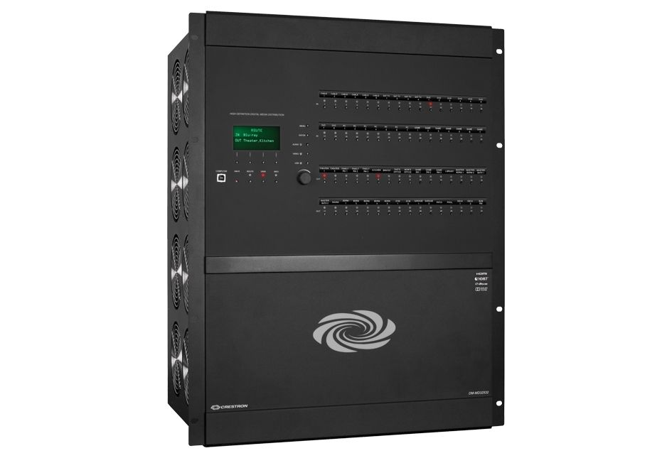 |  |  |  |  |  | MSRP - $18400  A+ Price - $11500
eBay
$3500 - $7000
Bought ($4,250)  Not received |  |  |  |  |  |  | Need 1 unit
 |  |  |  |  |  |  | Sub Total: $5500
Crestron Pro3 Series Advanced Control Processor  May need additional com port card(s) | 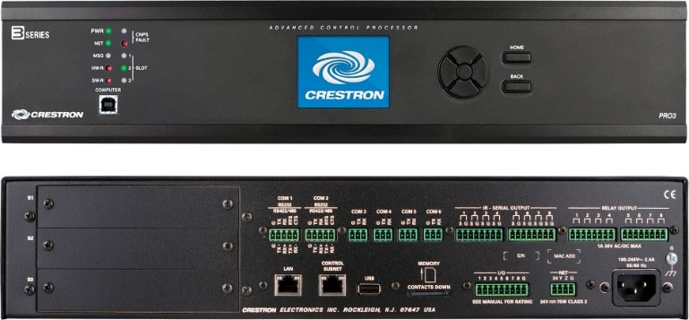 |  |  |  |  |  | MSRP - $5300.  A+ Price - $3300.
eBay
$1200 to $5600
Bought ($1,950.)  Not received |  |  |  |  |  |  | Need 1 unit
 |  |  |  |  |  |  | Sub Total: $2500
DMC-C-DSP DigitalMedia 8G+ Input Card  - $200 (4k)  - $300 (4k)  - $300 (4k) | 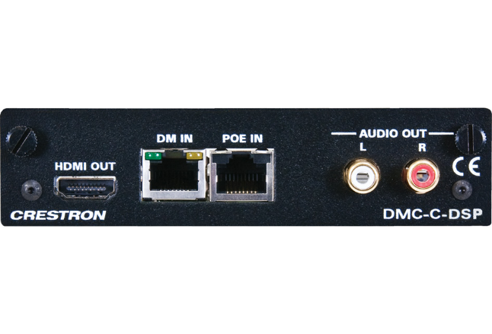 |  |  |  |  |  | Discontinued  Replacement DMC-4K-C-DSP-HDCP2 ( $815) A+
eBay
$100 - $200
Bought (3)  1 received |  |  |  |  |  |  | Need 9
 |  |  |  |  |  |  | Sub Total: $1200
DMC-HD-DPS or  DMC-4K-HD-HDCP2 | 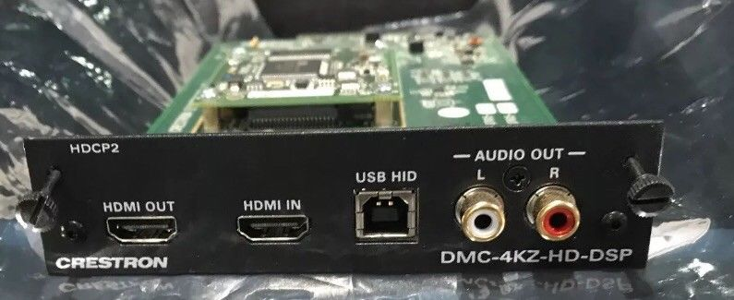 |  |  |  |  |  | {4k-HD card}  MSRP - $800  A+ Price - $500
 |  |  |  |  |  |  | Ebay: $100 - $500
Need:  - 3 for 2241 |  |  |  |  |  |  | Need 3
 |  |  |  |  |  |  | Sub Total: $750
DMC-SDI Input Card | 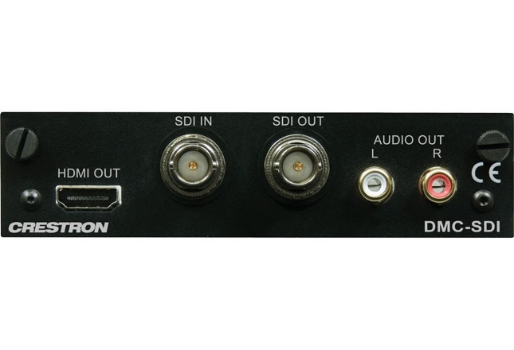 |  |  |  |  |  | MSRP - $1200  A+ Price - $750
eBay
~$150
{HOT Ebay Item}
Need:  - 8 for 2241 |  |  |  |  |  |  | Will need at least 8 cards
 |  |  |  |  |  |  | Sub Total: $1200
DMCO-33 Or  DMC-4K-HDO (Is preferred)  Bought (4) {$1,600}  4 received | 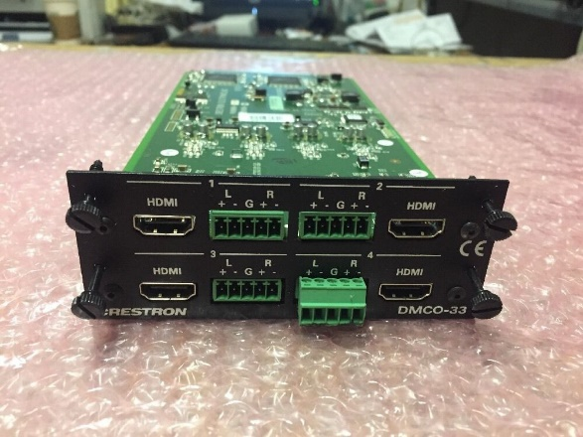 |  |  |  |  |  | Discontinued
eBay
$100 - $500

$400 - $600 4K-HD

Need:  - 1 for 2241  Option B  - 1 for Smithpage |  |  |  |  |  |  | Need 2 card
 |  |  |  |  |  |  | Sub Total: $1200
Blackmagic Design BMD-CONVMBHS24K6G Mini Converter - HDMI to SDI 6G | 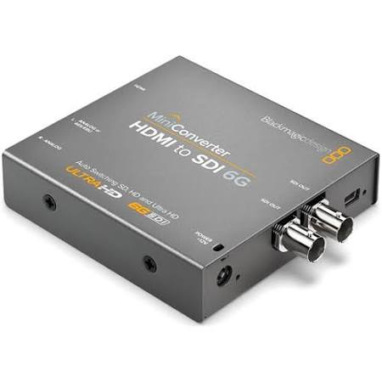 |  |  |  |  |  | Current
Markertek
$145.

Need:  - 4 for 2241  - Video Hub Tie in lines.  - Converts HDMI to SDI |  |  |  |  |  |  | Need 4
 |  |  |  |  |  |  | Sub Total: $580
Steaming Card  DMCO-77 (Dual output)  Or Equivalent H.264  Maybe difficult to obtain.  Replaced with  DMC-STRO | 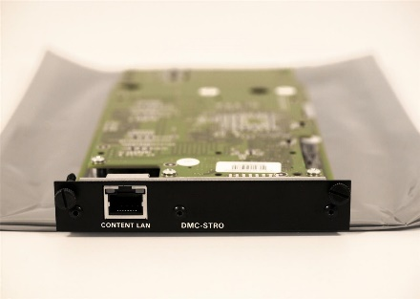 This is the replacement  Looking into other options |  |  |  |  |  | Discontinued (77)  Not on eBay yet
Replacement Card
(DMCO -stro)
MSRP - $3000
A+ Price - $1875

Ebay (~800. & Up)
Bought (2) {$1500}  0 received |  |  |  |  |  |  | Need 2 (stro) or  1 (DMCO-77)
 |  |  |  |  |  |  | Sub Total: $1600
Wall Plate DM Transmitter 200 DM-TX-200-2G HDMI | 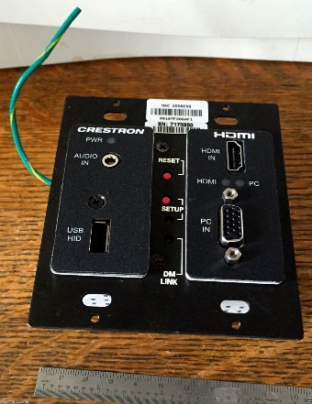 |  |  |  |  |  | Discontinued
eBay
$40 - $200
Bought (3) {$465}  1 received |  |  |  |  |  |  | Need:  4 for 2241  - 2 on Table 1  - 2 on Table 2
 |  |  |  |  |  |  | Sub Total: $360
DM-TX-4K-100-C-1G-B-T | 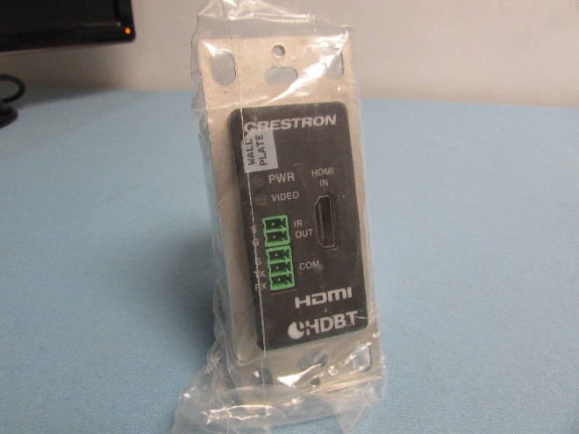 |  |  |  |  |  | MSRP - $700  A+ Price - $438
eBay
$125 - $300
Need:  - 3 for 2241  - On Lectern |  |  |  |  |  |  | Need 3
Bought (1) RX1($119)  - Received  Bought (2) TX($553)  - received  Bought (3) TX1($421)  (0) received |  |  |  |  |  |  | Sub Total: $500
DM-TX-201-C | 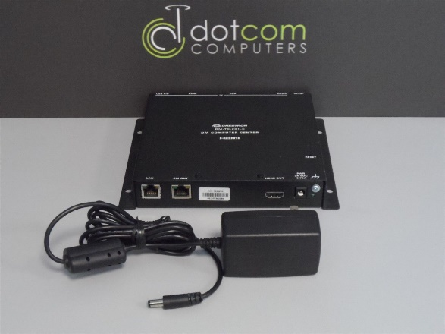 |  |  |  |  |  | MSRP - $1300  A+ Price - $813
eBay
$25 - $150
Need:  - 2 for 2241  - On Lectern |  |  |  |  |  |  | Need 2
 |  |  |  |  |  |  | Sub Total: $150
Touch Screens for 2241  TPMC-V12-Tilt-B  Plus:  Cable V-CBL-S6-B  Is needed  24Vdc, 2A Power Supplies maybe needed.  2223 doesn’t need video preview. TSW-1050 would work or perhaps one of our older units. Up to programmer… | 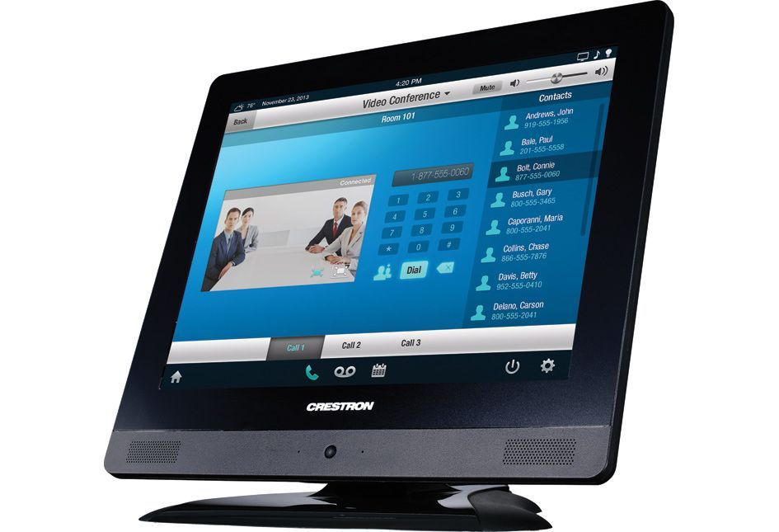 |  |  |  |  |  | Discontinued
eBay
$200 - $500
Need 1
- 2241

 |  |  |  |  |  |  | Sub Total: $400
TPMC-V-IMCW  Power supplies maybe needed | 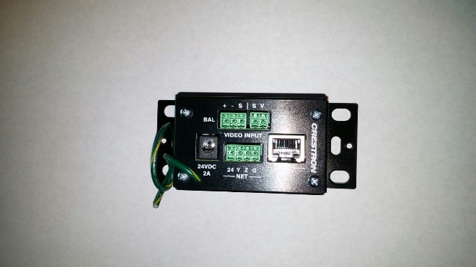 |  |  |  |  |  | Discontinued
eBay
$15 - $100
 |  |  |  |  |  |  | Need 1
 |  |  |  |  |  |  | Sub Total: $30
DMCO-55 Digital Media Output Card  Or 2 @ 4KZ-CO-HD | 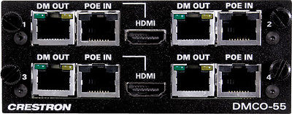 |  |  |  |  |  | Discontinued
eBay
~$400. - $500.
Bought (2) ($1000.)  (0) received |  |  |  |  |  |  | Need 4 outputs
 |  |  |  |  |  |  | Sub Total: $500 +
DM-RMC-4K-SCALER-C  DM-RMC-SCALER-C  Is cheaper but can’t handle 4K | 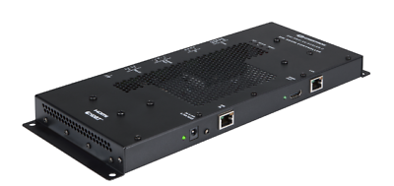 |  |  |  |  |  | MSRP $1800  A+ Price 1125
eBay
$400-900
Bought (3) ($2,845)  (1) received |  |  |  |  |  |  | Need 3  - Projectors
 |  |  |  |  |  |  | Sub Total: $1500
Smart Videohub  Need 2 - 40x40  Advanced 40 x 40 multi format SD, HD and Ultra HD SDI router with built in video monitoring, spin knob control, and 6G-SDI technology. | 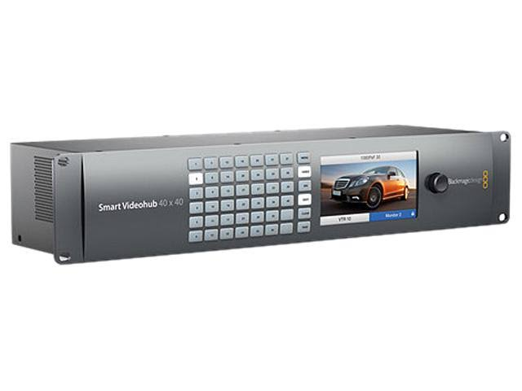 |  |  |  |  |  | each  $2995. - $40x40
Replaces :
- 40% of Patchbay
- CR Video Router
- CR RGB Router
- 3 Scan Converters
- 4 Video DA’s
 | Bought (1) ($2,845)  Not received |  |  |  |  |  | B&H Photo AV
 |  |  |  |  |  |  | Sub Total: $2995.
1000’ of CAT 6a shielded  Plus:  Tips are needed | 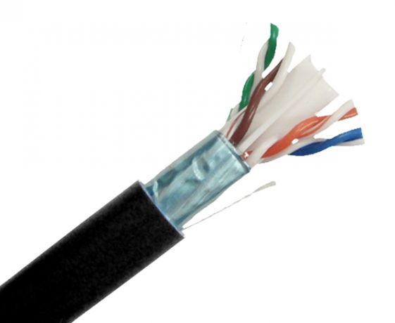 |  |  |  | Bought (3) ($300 each)  Not received |  | $180 -$280 each
 |  |  |  |  |  |  | At least 12 runs to rm 2241 (~1900’)
Need around 1900’
Need 2 spools
 |  |  |  |  |  |  | Sub Total: ~$500
 |  |  |  |  |  |  | Total: $21,565.
Rough Cost for rm2241 to SDI and to 6G/4K output |  | Rough Cost for control room to SDI and to 6G/4K |  | Update rm2103 to SDI and to 6G/4K output |  | Rough Cost for rm2223
$21,565. |  | $9,195. |  | $6,255. |  | $4,015.
Misc. Other Items:
XtremPro 61035 HDMI 4x1 Quad Multi-Viewer | 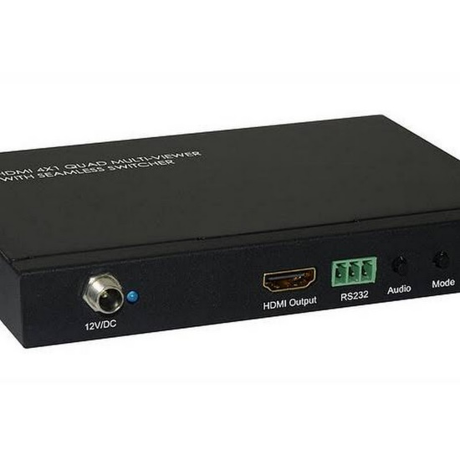  “Smith Page” will require a unit like this one. |  |  |  |  |  | $149
 |  |  |  |  |  |  | - “Smith Page”

