We are hoping that you can provide a couple of bullet points on features that you would need AVI to program in room 2241.  Here are a couple of examples:

Touchpad:

1. Turn projectors on and off
2. Ability to raise and lower program audio
3. Ability to raise and lower vocal audio
4. Pan, tilt, zoom control of the four cameras in the room
5. Control lighting system presets
   * 1 – 5 Same as we currently have via touch screen. Just need to update rm2241 so that it work just like rm2103 but with one less table and two less cameras.
   * Rm2103 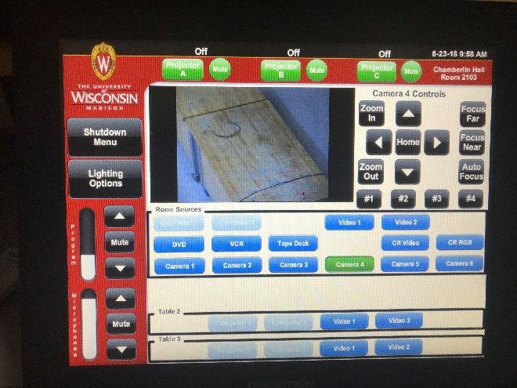
   * Rm2241 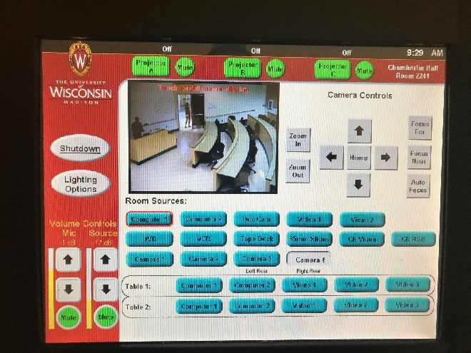
6. Control lighting system presets - Same as we currently have via touch screen.
7. Ability to show unique content on each of the projectors via the matrix switcher - Same as we currently have via touch screen. With the ability to select any active graphic or video source and send it to any or all 3 projectors.
8. Ability to select up to four inputs that can be combined into a quad split image – Coined as the “Smith Page”. A quad image is sent into the room DM via a 4 ch multi viewer. Inputs from the multi viewer come from the SDI Bridge, which includes 4 output lines from the room’s DM. The tough screen page will have full projector controls (ie room controls), the center area will be the quid image as large as possible. Now the trick. We quadrant off the image with virtual buttons to acquire whatever source one would like to view.
9. Oh, any important new function needs to be added in both rooms 2241 & 2103. We need to control the "Freeze" function on all the projectors. – We are currently using a IR to radio T/R and using the projectors remote to freeze the image. If there is any way to integrate this function into the Crestron for all 3 projectors (independently) with a hard button on the touch panel and/or with a remote control. This would be ideal. We may need to buy some hardware to make this work. Please let me know the cost any hardware needed.

• Freeze-frame functionality – can you send over the Panasonic projector model number?  We would like to see if there is an RS232 command that can be sent to the projector for this feature.

• For the Smith Page, you have the video sources being routed to the touch panel for preview and selection within a quad-split layout.  Do you have a Crestron DGE (Digital Graphics Engine) in your system design for getting video to the touch panel?

• Can you send us an equipment list of items that will be integrated into room 2241?

• Can you send us the projector make and model for room 2103, so we can verify the freeze-frame functionality requested?