D18: Kundt's Tube
Kundt's tube is used to find the velocity of sound waves in a solid brass rod. The brass rod, which is fixed at its center, vibrates at its natural frequency when rubbed with a rosined cloth. The diaphragm at the end of the rod then excites the air molecules in the glass tube. By adjusting the plunger at the opposite end of the tube, standing waves are produced which activate some cork dust sprinkled along the length of the tube. The cork dust piles up at the displacement nodes which are separated a distance of l/2. From this measurement, the frequency of the sound waves can be determined. Since the rod is fixed at its center, its length represents l'/2 where l' is the wavelength of sound in the rod. Knowing the frequency (from the standing waves in air) and the wavelength l' in the rod, the velocity v' = fl' can be found.
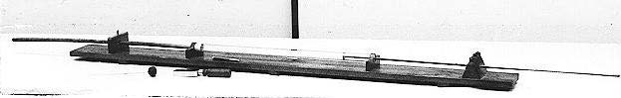
Apparatus:
- Kundt's Tube
- Chamois or soft cloth
- Powdered Rosin
- Meterstick
- Cork Dust (extra)
- 2 Bench clamps

Preparation:
Check that there is enough cork dust in the tube. Clamp the base of the apparatus to the lab bench so it doesn't move when the rod is being rubbed.
Demonstration:
Shake the tube so the cork dust is evenly distributed along its length. Sprinkle some resin powder on the Chamois or soft cloth, and rub the "end" half of the brass rod. While rubbing, have a volunteer from the class move the adjustable plunger until resonance occurs and the cork dust starts piling up at the nodes. Measure the distance between the piles of cork dust to give l/2. Since v in air is 33100 cm/sec, the frequency can be determined using f = v/l. The length of the brass rod (102 cm) gives the value of l'/2 in brass. Why? The fixed point of the rod forces a node in the center, and the free ends are antinodes.

